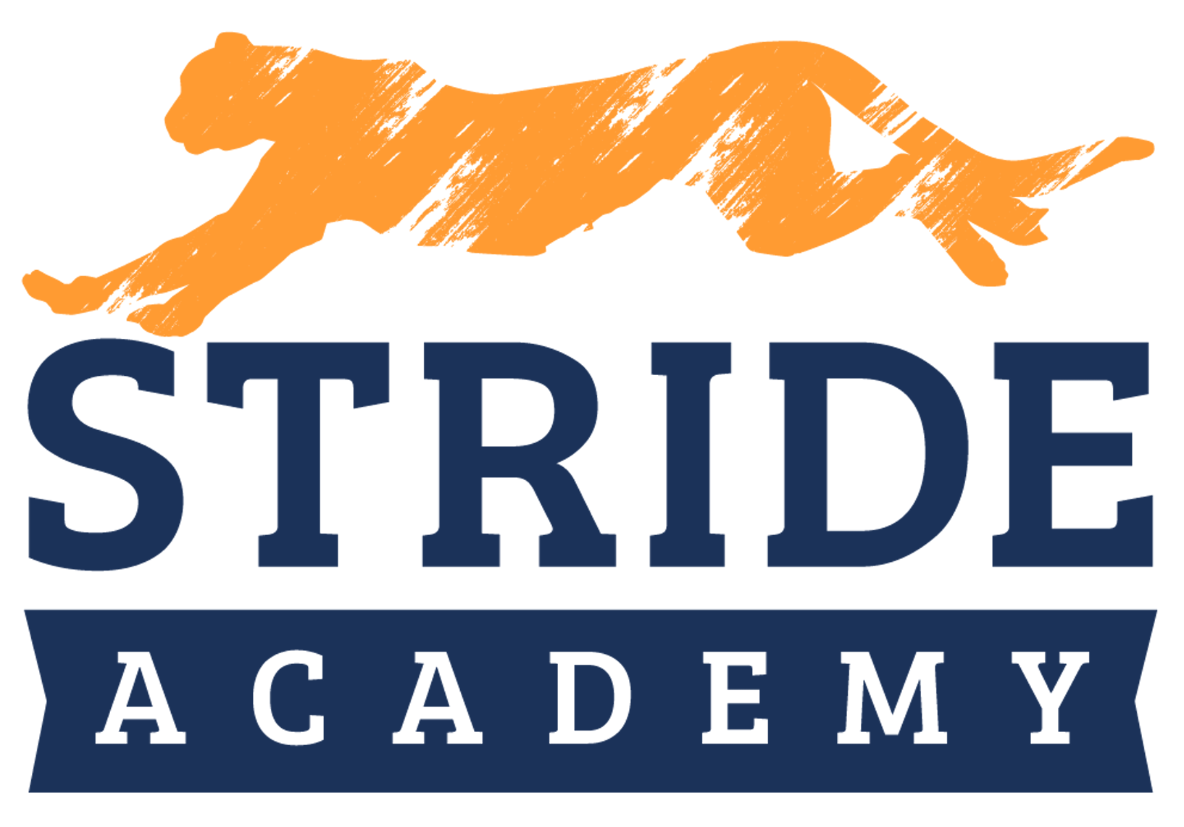
Annual Report on:
Curriculum, Instruction, Student Achievement, Financial & Governance
Minnesota Charter District #4142-07
2020-2021 School Year
Authorizer Information:
Pillsbury United Communities
1701 Oak Park Ave. North
Minneapolis, MN 55411
612-302-03409

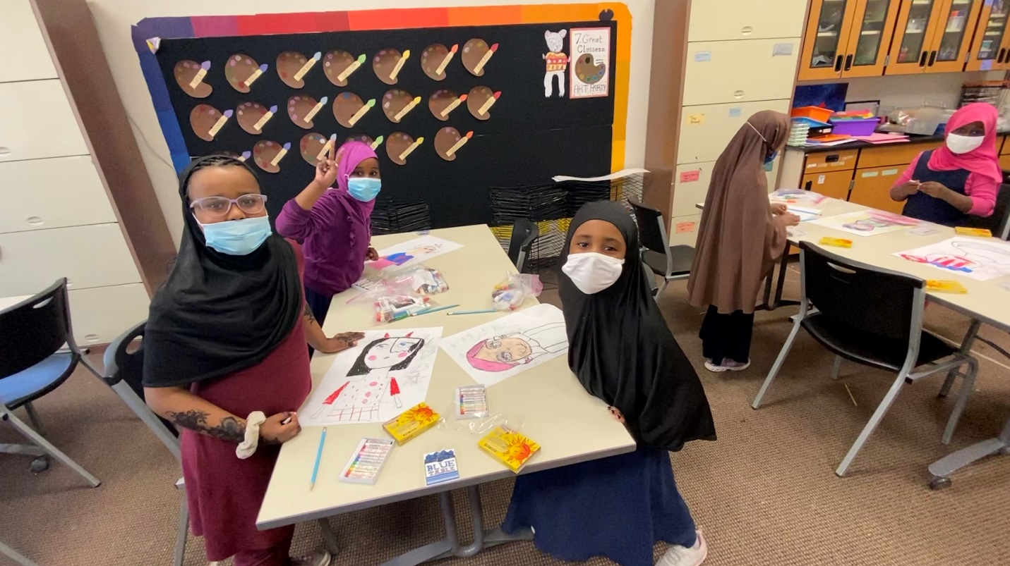

November 29, 2021

Table of Contents

Mission - Vision Statement 3
Introduction 3
Enrollment 4-5
Governance & Operations 5-6
Staffing 6-9
Finances 9
Academics 11
Curriculum & Supports 13
Innovations 16
Future Plans 16

Mission: Stride Academy nurtures individuals while fostering leadership and empowering students to attain their highest potential in a family-centered environment.
Vision: As part of its strategic plan STRIDE is committed to fulfilling its Five Strategic Pillars that support the school’s Mission. They include: Academic Excellence, The Whole Child, School Community, Lifelong Learning, and Fiscal Responsibility.

Introduction:
STRIDE Academy is a school community located in the southwest corner of St. Cloud, Minnesota serving students in kindergarten through 8th grade. The school address is 3241 Oakham Lane, St Cloud, MN 56301.
Established in 2005, Stride Academy Charter School is a St. Cloud based public charter school committed to the whole child, for its academic excellence, and for its contribution in actively serving and improving the community. STRIDE aims to teach students effective critical thinking skills, in addition to compassionate responses, and high emotional intelligence in order to foster successful leaders of today and the future. As a 100% open enrolled school, parents choose STRIDE because of our small class sizes, flexible grouping for math and literacy, a strong commitment to academics, and programs offered.
Students attending Stride Academy have opportunities classrooms that meet their academic needs. In addition, Stride Academy students will be taught the importance and value of being a good citizen within the greater community.
Relationships that allow STRIDE to leverage the high-quality education for its families.
Promise Neighborhood:
Math and Reading Corps:
STRIDE Academy completed the third year of a three-year contract with Pillsbury United Communities.

Student Enrollment
STRIDE Academy added 8th in 2020-2021. STRIDE has enjoyed increasing enrollment numbers over the past five years. Enrollment was lower than projected last year. This was due to the school’s decision to pivot to full Distance Learning.
Student Enrollment by Grade Level
Grade | 16-17 | 17-18 | 18-19 | 19-20 | 20-21
K | 102 | 40 | 52 | 60 | 50
1 | 102 | 53 | 50 | 59 | 55
2 | 81 | 62 | 58 | 65 | 54
3 | 86 | 46 | 68 | 68 | 52
4 | 90 | 48 | 48 | 70 | 65
5 | 73 | 45 | 48 | 48 | 62
6 | 73 | 28 | 41 | 47 | 48
7 | 50 |  |  | 48 | 44
8 | 50 |  |  |  | 39
Total | 707 | 322 | 365 | 465 | 469

Historical Enrollment: STRIDE Academy has experienced modest enrollment gains in each of the years since it’s near closure in the 2016-2017 school year. In 2017-2018 enrollment decreased by nearly 50% due to the news of the impending closure. Enrollment was at 469 students at the end of the 2020-2021 school year.

The Table below lists the historical enrollment at STRIDE Academy.

Fiscal Year | Enrollment
2006 | 160
2007 | 226
2008 | 266
2009 | 254
2010 | 264
2011 | 349
2012 | 403
2013 | 474
2014 | 514
2015 | 549
2016 | 676
2017 | 707
2018 | 322
2019 | 366
2020 | 465
2021 | 469

Student Demographics ­ Historical
Descriptors | 14-15 | 15-16 | 16-17 | 17-18 | 18-19 | 19-20 | 20-21
% F/R Lunch | 23.4 | 39.8 | 53.8 | 73.9 | 77.1 | 80.4 | 78.1
% SPED | 8.5 | 13.8 | 10.1 | 9.6 | 10.7 | 10 | 12.1
% White | 82.7 | 68.8 | 59.4 | 36 | 29.6 | 25.1 | 19.4
% Black | 10.2 | 26 | 34.5 | 56.5 | 64.8 | 68.7 | 76.0
% Hispanic | 2.4 | 1.4 | 2 | 4 | 4.3 | 3.9 | 3.4
% Asian/Pacific | 4.4 | 3.2 | 2.8 | 3.4 | 0.5 | 0.8 | .9
% Am. Indian | 0.3 | 0.2 | 0.3 | 0.6 | 0.5 | 0.8 | .4
% ML | 4.1 | 14.1 | 19.0 | 43.5 | 50.9 | 51.8 | 55.7

Community Eligibility: In 2018-2019 STRIDE applied to participate in the Community Eligibility Program through the Minnesota Department of Education. In addition to free breakfast and lunch for all students. Because of the Pandemic, fresh fruit or vegetable snack had to be postponed for the 2020-2021 year.
Special Education Program: In 2020-2021, STRIDE’s school wide Special Education rate was 12.1%. In comparison, 10% of students are receiving Special Education services in 2019-2020.
Multilingual Learner Program Trends: Stride Academy serves a higher population of Multilingual Learners. In 2020-2021, STRIDE’s school wide ML rate was 55.7%. In comparison, 51.8% of students were receiving Multilingual Learner services in 2019-2020.
Governance and Management
STRIDE Academy is governed by a school board of directors elected in accordance with its bylaws, as defined by Minnesota Statute 124E.07, subd. 6. The board of directors decides and is responsible for policy matters related to the operation of the school including; budgeting, curriculum programming, personnel, and operating procedures. The STRIDE Academy Board of Directors ensures;
The school carries out its mission and goals;
Evaluates the execution of charter contract goals and commitments;
Evaluates student achievement, post secondar/workforce readiness, and student engagement/connection goals.
Establish a teacher evaluation process under section 124E.03, subdivision 2, par. (h).
Provides professional development related to the individual's job responsibilities.

The School Board delegates the overall management of the school to the Executive Director, who is hired and supervised by the School Board. The administrative team consists of the executive director, the principal and assistant principal who are each responsible to the academic success of the school along with creating and maintaining a safe school environment.
The School Board employs and contracts with necessary teachers and other education professionals, as identified by Minnesota Statute 124E.12, subd. 1 and defined by section 122A.15, subd. 1, who hold a valid license to perform the particular service for which they are employed in the school.

The school employs necessary employees who are not required to hold teaching licenses to perform duties other than teaching and contracts for other services.

As defined in Statute 124E.10, subd. 1, the school may discharge teachers and
non-licensed employees. The charter school board is subject to section 181.932. When offering employment to a prospective employee, a charter school must give the employee a written description of the terms and conditions of employment and the school's personnel policies.
Teachers in a charter school must be licensed public school teachers for the purposes of chapters 354 and 354A.

The Board embarked on a strategic plan during the 2017-2018 school year. It concluded its strategic planning and visioning process in in March, 2018. This involved several community wide planning sessions and work with the Board and Administration. The final Strategic plan is focused on the schools work toward:
Academic excellence
Personalized learning
A welcoming school community
Active engagement in the community through intentional collaboration.
Meeting the needs of whole child (i.e. academic, social, and emotional).
Promoting Lifelong learning
Engaging students and establishing family supports that go beyond the school day.

2020 – 2021 Board Members
Board Member | Position | Elected | Term Expires | Three Trainings
Suzy McIntyre-Teacher | Secretary | Feb-19 | Jul-21 | Yes
Andy Lyman - Teacher | Director | Jul-19 | Jul-22 | Yes
Hannah Dornbusch - Parent | Director | Jul-19 | Jul-22 | Yes
Aaron Lundblad - Community | Director | Jul-16 | Jun-20 | Yes
Sara From - Parent | Chair | Nov-16 | Jun-20 | Yes
Matt Chapmann - Parent | Treasurer | Appt. 7/30/20 | Jun-21 | Yes
Hassan Yussuf – Community | Director | Appt. Nov-20 | Jun-21 | Yes

Required board trainings. Minnesota state statute 124E.10, Subd.4(f) states: Every charter school board member shall attend annual training throughout the member's term on the board. All new board members shall attend initial training on the board's role and responsibilities, employment policies and practices, and financial management. A new board member who does not begin the required initial training within 6 months after being seated and complete that training within 12 months of being seated on the board is automatically ineligible to continue to serve as a board member. The school shall include in its annual report the training attended by each board member during the previous year.

Staffing
Administration/Student Support
Eric Williams – Executive Director
Gwen Anderson – Principal
Nathan Schwieters – Assistant Principal
Marlene Grindland – Special Ed. Director
Doug Millaway – School Psychologist
Steve Swenson - Technology Coordinator
Cory Heinen - Building & Grounds Coordinator
Judy Theisen – Human Resource Coordinator
Katie Muhlenpoh – Admin. Assistant/Secretary
Mara Kramer – Accounts Payable
Myra Schup – RN - On/Off-Site
Dahir Hassan - Cultural Liaison/Interpreter
Jess Sowers – Social Worker
Staff
Ahmed, Mulkiya, Paraprofessional
Alvord, Ben, Teacher
Bechtold, Tanner, Tech Paraprofessional
Berger, Rochelle, Paraprofessional
Bile, Fardowsa, Paraprofessional
Birr, Courtney, Paraprofessional
Blomme, Victoria, Teacher
Broughton, Ashley, Paraprofessional
Chopp, Ted, Teacher
Cote, Grace, Teacher
Daniels, Shannan, Teacher
DePatto, Jessica, Paraprofessional
DesCamps, Allyson , Teacher
Dingmann, Sue, Paraprofessional
Dockendorf, Matthew, Teacher
Elliott, Robyn, Paraprofessional
Falk, Lisa, Teacher
Feigum, Jennifer, Teacher
Fleege, Jason, Teacher
Fritz, Kathleen, Nutritional Assistant
Gartland, Amy, Teacher
Geisler, Jenifer, Teacher
Hamilton, Ellie, Paraprofessional
Hamilton, Emma, Paraprofessional
Hashi, Hani, Paraprofessional
Hassan, Fardowsa, Paraprofessional
Haws, Kelly, Teacher
Hilsgen, Corinne, Paraprofessional
Holden, Mary, Teacher
Horner, Jenifer, Teacher
Huus, Molly, Teacher
Hyde, Joesphine, Paraprofessional
Iverson, Susan, Teacher
Janey, Susan, Teacher
Kalla, Nancy, Health Assistant
Kelsch, Judith, Teacher
Kirchner, Christopher, Teacher
Kirchner, Noel, Teacher
Kneip, Bobbie Jo, Teacher
Kockler, Michele, Teacher
Kruse, Sidney, Teacher
Lancaster, Abigail, Teacher
Larsen, Judi, Speech Pathologist
Leintz, Samantha, Teacher
Lerud Katie, Teacher
Louis, Erica Lynn, Teacher
Lyman, Andrew, Teacher
Maiers, Laura, Teacher
McIntyre, Suzanne, Teacher
Millaway, Kiera, Paraprofessional
Mohamed, Fartun, Paraprofessional
Molitor, Mary, Paraprofessional
Nohner, Shonda, Teacher
Noor, Shamhaad, Paraprofessional
Olson, Angela, Paraprofessional
Pederson, Madison, Teacher
Peterson, Erin, Teacher
Peterson, Heather, Paraprofessional
Rothstein, Melissa, Teacher
Rothstein, Stefanie, Social Emotional Coordinator
Saad, Sina, Paraprofessional
Silverberg,Kayla, Teacher
Skudlarek, Leanne, Teacher
Strand, Katherine, Teacher
Swenson, Steve, Technology Coordinator
Szymanski, Lindsay, Teacher
Thelen, Travis, Tech Paraprofessional

Thom, Ruth, Personalized Learning Coordinator
Titrud, Cailey, Paraprofessional
Voss, Sara, Teacher
Watrin, Jamie, Teacher
Wendorf, Jessica, Teacher
Weyer, Valerie, Teacher
Yalahow, Nurto, Paraprofessional

Finances
STRIDE Academy contracts with BerganKDV (BKDV) to provide financial and business services for the operation of the School and the Affiliated Building Company. Bergan KDV provides services related to accounting, the generation of financial statements, Special Education financial reporting, managing Federal grants, and payroll. Bergan KDV has been providing accounting and business management services to STRIDE Academy since 2005. Kelly Rimpila serves as the Finance Manager for the School and the Affiliated Building Company. Kelly has 8 years of direct charter school finance experience and an additional 3 years of charter and traditional school auditing experience.

In addition, STRIDE Academy also contracts with Bergan KDV for the preparation of its annual independent financial audit. The accounting firm of ABDO Eick and Meyers, an independent firm with extensive GASB auditing experience performed the audit for the School and the Affiliated Building Company. Financial Statements are presented to the Board’s Finance Committee, the Board of Directors and the Authorizer on a monthly basis; the Finance Committee also reviews monthly expenditures. For additional review and accountability on a monthly basis.

Financial Condition of STRIDE Academy
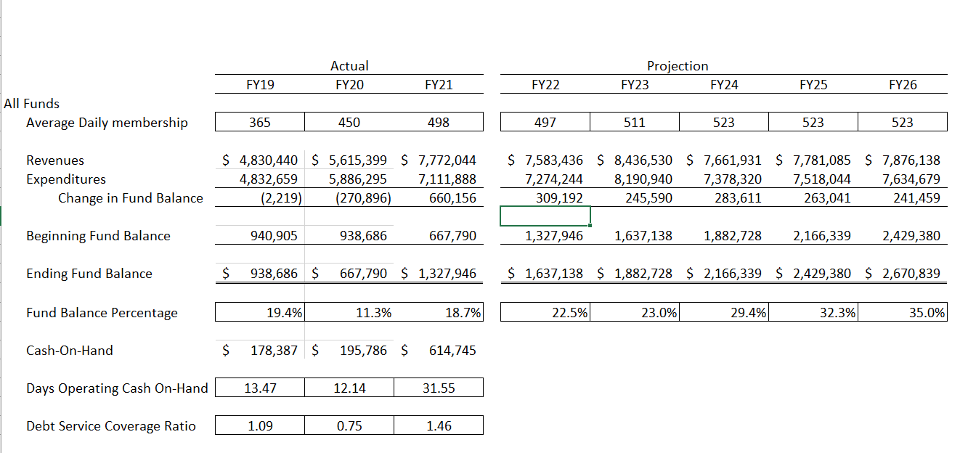

Enrollment FY21 – Original budget – 498 ADM FY21 – Revised budget – 453 ADM and FY20 – year‐end ADM 449.4
All Funds – 12‐months or 100% of FY20 is complete and the FY21 audit report has been issued.
Cash – Approximately $614,745 at month‐end, nearly 32 days of operating cash‐on‐hand. The cash‐flow statement continues to show the school will likely have adequate cash for the remainder of the year if the state does not increase the hold back above the current 10%.
With 100% of the year complete, revenues earned were $7,772,044 and expenditures incurred were $7,111,888%.
Items to note: The revised budget anticipated that the school would have an operating surplus of $523,360. The school’s actual FY21 operating income was slightly better than anticipated at $660,156

Financial Management Practices: STRIDE Academy reviews its financial position monthly with the financial committee and the full board. In addition, the school participated in bi-monthly conference calls to review the operations of the school with the school’s bondholders. Budgets are updated as any new information affecting STRIDE’s bottom-line is made available. Key equations are reviewed to ensure the school meets all of its bond covenants.

Impact of this Issue on the School’s Finances: The bondholders provided a conditional waiver was approved and signed. This provided relief of the 2020-2021 principal payment. In April 2021 the school was able to pay the portion of principal bondholders deferred in order to help prevent school closure in 2017. The school is now out of default. In addition, the school applied for a PPP (payroll protection program) loan of $693,752. This was subsequently forgiven.

Academics
MCA III (Minnesota Comprehensive Assessments)
Due to COVID-19, 2020-2021 accountability data is not available.

National Normed Assessments
Each year, STRIDE administers a nationally normed assessment in each grade. Last year the school administered the Northwest Education Assessment’s (NWEA’s) Measures of Academic Progress (MAP), in both reading and math, in grades K through 6 in September, January and May. The school uses the data from the Fall assessments to set growth targets for each student. The teachers share this information with the parents during parent teacher conferences.
The table below lists the specific targets for each grade in reading and math. The school was to ensure that at least 55% of the students who scored below the 51st percentile on the Fall 2019 assessment, demonstrated at least the following RIT growth on the Winter 2020 assessment.

Grade | Reading  (Margin of error +/- 1) | Math  (Margin of error +/- 1)
K | Not tested | Not Tested
1 | 12 - 7/18 38.8% | 13 - 6/13 46.1%
2 | 11 – 4/21 19% | 11 - 3/18 16.6%
3 | 9 - 11/30 36.6% | 8 - 20/29 68.9%
4 | 7 - 20/31 64.5% | 7 - 12/31 38.7%
5 | 6 - 10/25 40% | 6 – 17/34 50%
6 | 5 - 5/23 21% | 5 – 11/27 40.7%
7 | 4 - 9/16 56.2% | 4 - 6/18 42.8%
8 | 3 - 13/23 56.52% | 3 - 17/24 70.8%

Classroom Size: The philosophy of STRIDE continues to be one of low student to teacher ratio. Thus, we limit the number of students in each class. Listed below are the adopted class sizes for each grade.
Kindergarten 20
1st Grade 20
2nd Grade 22
3rd Grade 24
4th Grade 24
5th Grade 24
6th Grade 24
7th Grade 24
8th Grade 24

The continued goal of STRIDE Academy is to maintain small class sizes which increases potential for more interpersonal connections between teachers and students. The Board regularly evaluates the number of sections and the number of students per section.

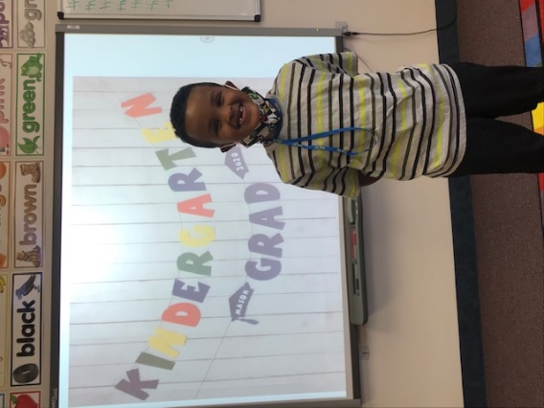
Curriculum and Academic Supports
Dyslexia: STRIDE Academy offers a support program for students that have observed specific reading, spelling or writing differences. The program, “STRIDES for Reading” aims to give STRIDE students the skills to be successful lifelong learners. Initially, classroom teachers use paper pencil tasks, file reviews, and teacher developed interventions and assessments to determine if qualifying criteria is met for further dyslexia screening. When that occurs, the Dyslexia Specialist conducts an assessment of reading skills for the child to determine if intervention is appropriate. The intervention the school has purchased is the Barton Reading Program. The program is a teaching method based on the highly structured Orton–Gillingham approach and is designed to be used by staff or family members who may not have formal literacy training.

Multilingual Learner strategies: Teachers receive professional development on a number of interactive strategies to incorporate reading, writing, speaking, and listening into their content area classes, and embed them within their daily lessons. These activities support language objectives, which are essential for meaningful learning. Classroom teacher collaboration with the multilingual teachers has been useful in integrating these strategies.

PBIS: Teachers use research-based behavioral and academic instructional strategies for all students. Teachers use data when making decisions on behavior and instruction in all areas of the school, and during the school day. Additionally, PBIS increases the capacity of teachers to help students with disabilities and prevent academic and/or social failures of all students. Implementing a school-wide PBIS plan has helped teachers shift from discipline strategies that are punitive to proactive intervention plans. According to anecdotal reports from the teachers, this shift in strategy has also helped students with more challenging behavioral and emotional needs.

MTSS (Multi Tiered Systems of Support): MTSS is a school-wide approach to support students at STRIDE. Universal screening for all students occurs early in each school year. Grade level teachers, the social worker, psychologist, principal, special education teachers, and other specialists within the building make up the MTSS team. The team meets bi-monthly (more if needed) to review and assess referred students and plans interventions to be implemented by the classroom teacher and monitored for progress or lack of progress.

Guided reading: Teachers work with small groups of students who demonstrate similar reading behaviors and can read similar levels of texts. The text is easy enough for students to read with a teacher's support but at the same time, more challenging on their own. The students are generally able to read the text with some fluency. Teachers are given professional development to help them choose selections that best help students expand their reading fluency and comprehension.

Math: STRIDE completed its second year of its schoolwide curriculum adoption in Math. Houghton Mifflin’s Go Math curriculum was selected because of its comprehensive approach and its support of the Minnesota Math Standards. The Go Math curriculum emphasizes “Essential Questions and Big Ideas” with depth of understanding as the goal. The tools provided in the Go Math curriculum allow teachers to engage students and meet them where they are and improve their conceptual understanding and problem-solving skills.

I-Read: I-Read is a software for primary (K-2) students. The adaptive technology within the software adjusts instruction to determine a student’s level and provides specific instruction and guided practice to build mastery in the areas that need development. The students’ virtual setting takes place in a fictional classroom with personalized avatars that help them engage in learning center activities with virtual peers. As a student progresses, he/she is able to share, and demonstrate in reading skill development success.

Viewpoint: Is a data warehouse program that integrates current, relevant student data (assessment, discipline, health, demographic) from multiple sources and is continually uploaded to provide teachers and administrators a user-friendly format to inform potential intervention strategies.

PLC (Professional Learning Communities): As part of the school’s Q-Comp plan Teachers meet each week in Professional Learning Communities to discuss the implementation and reflection of strategies used by teachers in their classroom. The goal is for increased student achievement and overall school improvement. The PLC’s reflective process allows both the teacher and the PLC team to grow. STRIDE’s PLC goals align with School’s contract goals with its authorizer.

Social Emotional Learning: STRIDE’S SEL program provides school-wide pathways for students to deeper understand themselves, their peers, and those who care for them. Teachers increase ownership - and the responsibility for - the health and well-being of their students. Building this capacity is accomplished in several ways. An example of this would be, building up student capacity. Students will be selected and trained to guide their peers through real-world social-emotional learning (SEL) experiences using a process of simple, clear steps for building awareness, naming emotions, grappling with root causes, and retraining minds to react in a healthier manner. By pairing students with other students and designing learning experiences focused on the social emotional learning standards, students will begin to know what healthier connections to self, to others, and to the school community look and feel like. Three resources are utilized. For K/1, Emotional ABC's (Moody Monster helps kids to broaden vocabulary and understanding of emotions). For 2/3/4, we use Sanford Harmony and use Marc Brackett's RULER components (Recognize, Understand, Label, Express, Regulate). For 5/6/7, we use CASEL's resources and some of Sandy Hook Promise's "It Starts with Hello" and "Say Something.”

Seesaw: Seesaw is a student-driven digital portfolio. Seesaw empowers students of any age to create, reflect, collaborate and share what they have done in a classroom with their family. It allows family members to use the Seesaw app to keep up to date with their child’s learning, and easily communicate between school and home.

Differentiation: STRIDE Academy is committed to provide differentiated instruction. Teachers implement differentiated math and reading instruction starting in kindergarten through 8th grade. These classrooms allow for both accelerated learning and scaffolded instruction to meet the needs of all learners. Parents are informed of this before they enter STRIDE Academy.

Measurement of Academic Progress MAP goal setting: Teachers have been trained to analyze NWEA’s MAP data in Reading and Math. Teachers conduct goal setting conferences with their assigned students and their parents/guardians. The conferences help the student and the parents/guardians plan for increased academic achievement in reading and math.

Homework: A substantial number of STRIDE families do not speak English and struggle to provide assistance with some of their child’s assignments. To that end, the school has elected to limit the practice of assigning regular homework. The students still benefit from independent practice and guided practice on concepts or skills are given within the school day.

Grading: Students in Kindergarten through second grade utilize a standards-based report card. Grades 4-8 are defining their practices of grading to be more reflective of actual student learning and mastery.

Language Arts: Journeys Is a comprehensive K-6 English language arts program. It provides an instructional system for reading both literature and informational texts, for acquiring foundational skills, and for developing mastery of speaking, listening and writing. Grades 7-8 have implemented two years of Into Literature for the same skill practice and assessment.

Science: Grades K-5 has access to a number of hands-on activities and manipulatives that enhance the exploration of the earth and life science curriculum. The National Geographic Science curriculum aligns with the Minnesota State Science Standards. Generation Genius also supports our science standards in grades K-8. In grades 6-8, Science Fusion is preparing students for earth, life, and physical science as we transition to using the new science standards.

Newsela: Is an instructional content platform that publishes daily news articles to support instruction for ELA, Social Studies, Science, and SEL. Every article comes in 5 reading levels, tailored to the skill level of each reader. Assessments are integrated directly into articles to help students engage with the content and to give teachers and administrators actionable insights on students’ reading activity.

Google’s Suite of applications: Google Classroom, Docs, Sheets, and Slides support teachers’ instruction and practice and the ability to collaborate.

Flexible Grouping: The educational program at STRIDE Academy is focused on providing differentiated instruction. STRIDE Academy implements differentiated math and reading instruction starting in kindergarten and continuing through 8th grade. These classrooms allow for both accelerated learning and scaffolded instruction to meet the needs of all learners.
STRIDE Academy differentiates instruction in math and reading. Parents are informed of this before they enter STRIDE Academy. Differentiating instruction ensures that students will have appropriate challenges to provide opportunity for growth. If they are below grade level, focused interventions help students receive focused attention in areas of need. If students are above grade level, flexible grouping helps students receive enrichment-focused opportunities with attention to a rigorous program focusing on standards, problem solving, and critical thinking. Given our Student-centered focus, differentiated instruction is an accepted practice by parents, students and staff. To accomplish appropriate differentiation, all students are pre-assessed in math and reading. The assessment data is used throughout the year to place students in their flexible skill groups. Student confidence and success increase when they are instructed with a differentiated model. Multi-Tiered Systems of Support allows the School to monitor student data and make adjustments throughout the year.

Innovations
During the 2020-2021 school year the school continued to build capacity for Personalized and Social Emotional Learning for teachers to use in the classroom.
Ipads, Chromebooks and internet hotspots were purchased to increase student and family access.

Future Plans
Ongoing Transition plan for Executive Director
Continue to hire high quality faculty and staff.
Planning for potential grade expansion. This includes a facilities analysis and strategic planning with the school community.
Currently, the school is in discussions to purchase additional property to the north of the school.

