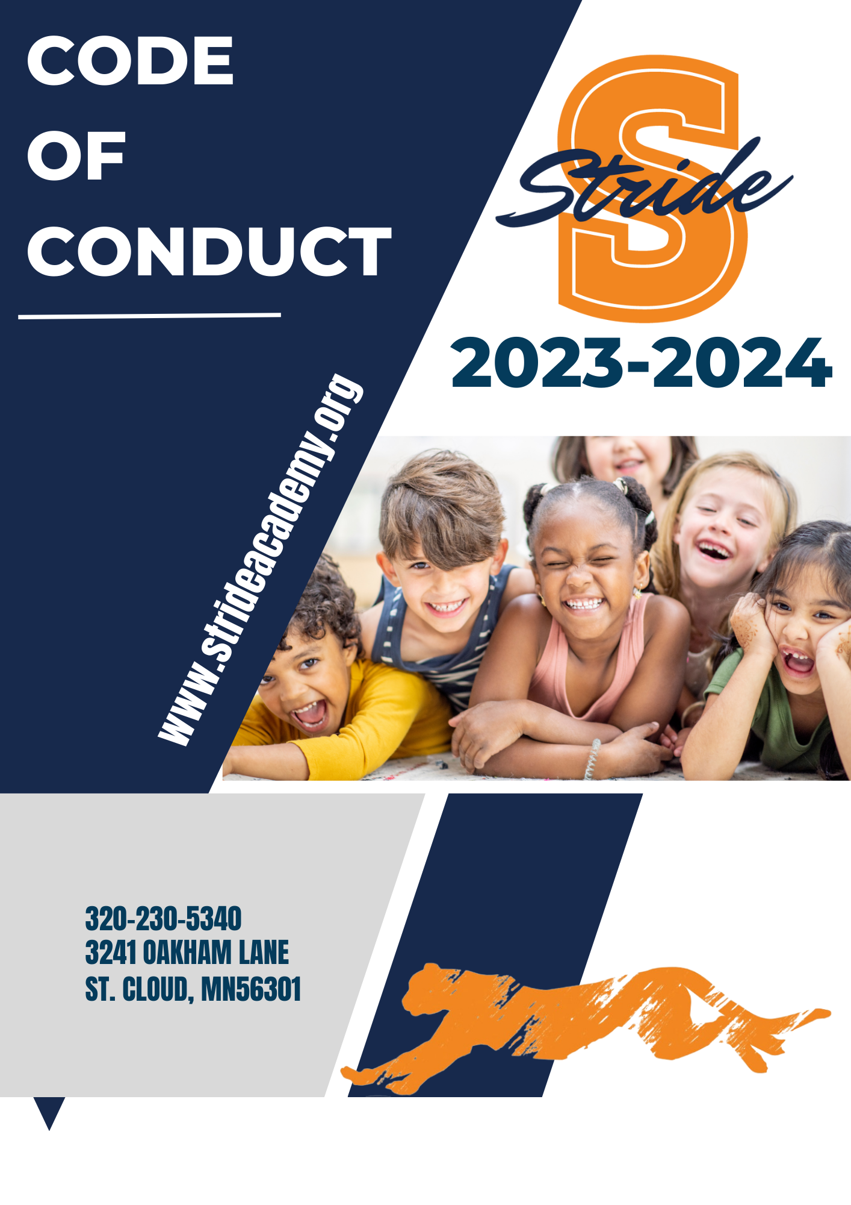

TABLE OF CONTENTS

Mission, Beliefs, Vision 3

Strategic Initiatives 4

Student Rights, Responsibilities and Opportunities 5

Attendance 5

Bullying Prohibition 5

Equal Opportunity 5

Fair Treatment 6

Free Speech and Expression 6

Learning and Academic Work 7

Medications 7

Non-Discrimination/Harassment 7

Personal Property and Privacy 8

Student Government 9

Student Records 9

Technology Usage and Safety 9

STRIDE Systems of Support 10

Standards of Student Behavior 11

Levels of Behavior, Intervention and Response 12

Level 1 12

Level 2 13

Level 3 14

Level 4 15

Level 5 16

Alphabetical Listing of Behaviors 17

Additional Information 23

Glossary of Terms 25

Resources and Assistance to Resolve Issues 28

Code of Conduct:
Rights and Responsibilities for Students, Families, and Staff

Foreword

This Code of Conduct is a guide to student behavior. STRIDE Academy Staff, Administration, and Board of Education create and adopt policies to guide the actions of everyone in the district. The district team develops procedures to show how these policies will be implemented at STRIDE Academy and the Executive Director, principals and program administrators can then add specific school guidelines and expectations. Teachers and other staff work with students to set and follow the expectations for how they will work together in each classroom. Adult staff members are held to high standards of behavior and are subject to all applicable laws, Board of Education policies, and Human Resources rules and practices.
The rules and regulations regarding student behavior, intervention, and discipline in this document fulfill the Board of Education’s policies as stated in STRIDE Academy’s policy manual.
This Code of Conduct applies to incidents and situations that occur on school premises, on school district property, at school functions or activities, on school transportation, or on school computers, networks, forums, and mailing lists. This document may also apply to incidents that occur off school premises to the extent that it substantially and materially disrupts student learning or the school environment.

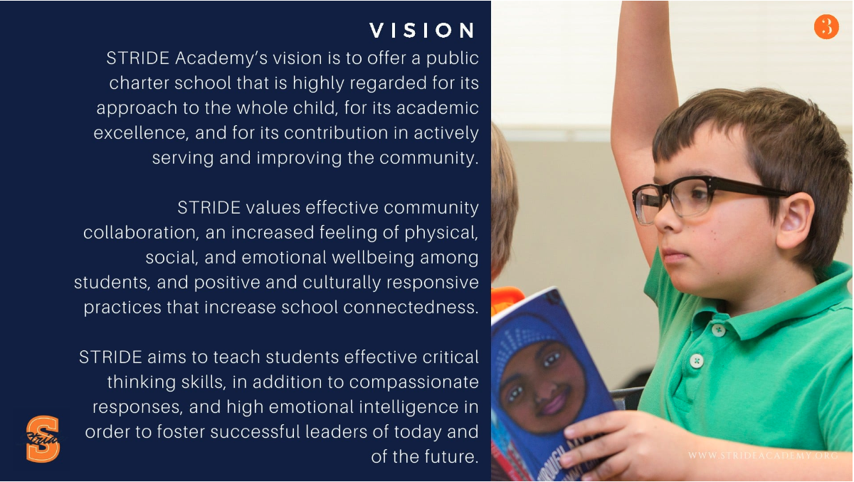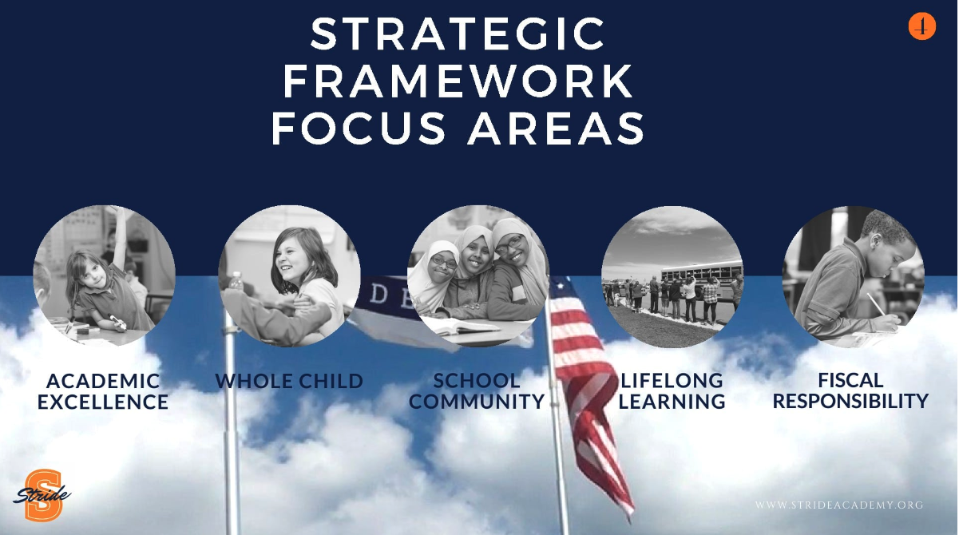

Student Rights, Responsibilities and Opportunities
Students who attend STRIDE Academy have various rights and opportunities. Students also have responsibilities to teachers, other staff and fellow students. Students have other rights guaranteed by the Constitution and by state and local laws. The rights and responsibilities in this Code of Conduct are not all-inclusive and do not cover every situation that may arise. The table below describes student rights, opportunities, and responsibilities at STRIDE Academy.

Attendance
Rights | Responsibilities
Eligible resident students have the right to a free public education according to state and federal law.  Absence or tardiness of students because of religious holidays and observances shall be recorded as excused absences or tardiness at the written request of the parent/guardian.  For more detail, click this link to find: STUDENT Attendance Policy 503 | Students and families are responsible for following the school’s attendance and tardiness rules and procedures.  Students and families are responsible for notifying the school (e.g., written note, phone call, email) before an absence or upon returning to school after an absence.  Students are responsible for obtaining a pass from a staff person when late for class or if there is a need to leave class.  Students and families are responsible for notifying the school if the student must leave during the school day.

Bullying Prohibition
Rights | Responsibilities
Students have the right to a learning environment that does not permit, condone, or tolerate bullying or cyberbullying by either an individual or group.  Students have the right to be free from retaliation when making good faith reports of bullying or cyberbullying.  For more detail, click this link to find: Policy 514 Bully Prohibition | Students who believe they have been the target or victim of  bullying or have knowledge or belief of conduct that may constitute bullying shall report the alleged act immediately to school staff.  Students have the responsibility to intervene on behalf of any individual who is a target of bullying and report any acts of bullying immediately. We expect STRIDE students to be Upstanders and not Bystanders in the presence of bullying.
Equal Opportunity
Rights | Responsibilities
Students have the right of equal opportunity, as allowed by law, to participate in all school activities and school education programs for which they are eligible.  For more detail, click this link to find: Policy 401 Equal Employment Opportunity | Students are responsible for following the rules and procedures of the school-sponsored activity in which they participate. Students may not discourage the participation of other students.

Fair Treatment
Rights | Responsibilities
Students have the right to due process as defined in the  Minnesota Pupil Fair Dismissal Act when involved in a violation of district rules. Included is the opportunity to hear the nature of the violation and to give their account of the situation.  Students have the right to expect privacy regarding actions taken.  Students have the right to be informed of all applicable  classroom and school rules, expectations and procedures.  Students have the right to be treated respectfully by school employees and other students.  Students have the right to be free from unreasonable physical contact from teachers and other students. Immediate intervention by staff to protect a student or other individual from physical injury, however, is allowable. | Students are responsible for responding to all directives or inquiries from staff, for following all laws, policies, rules, and expectations that apply to them.  Students are responsible for knowing and following all applicable classroom rules, expectations, and procedures.  Students are responsible for treating all persons respectfully.  Students are responsible for respecting the space and freedom of those around them.  Students are expected to treat the property of others and the district responsibly.  Students are responsible for engaging in conduct that does not threaten to injure themselves, other persons, or property.

Free Speech and Expression
Rights | Responsibilities
Students have the right to free speech so long as such speech does not violate the rights of others. | Students are responsible for expressing opinions, publishing written materials, and distributing literature in such a manner that:  - is not libelous, obscene, discriminatory, or sexually explicit,  - does not contain references to alcohol, chemicals, tobacco, or other products that are illegal for use by minors,  - does not interfere with the rights of others,  - does not disrupt the atmosphere of learning in the school, and  - follows school rules and procedures regarding time, place, and manner.  Permission of the school administrator is required for distribution or posting of written materials.

Learning and Academic Work
Rights | Responsibilities
Students have the right to attend school and gain an education as provided by law. Attendance at a particular school is a privilege, not a right.  Students have the right to attend school in a safe environment that is free from disruptive behavior.  Students have the right to complete assignments missed during an absence.  Students who are unable to attend at the school site due to illness, injury or placement have the right to home/hospital instruction as regulated by state guidelines.  For more detail, click this link: Minnesota Statute § 120A.366 | Students are responsible for daily attendance, completing class assignments on time and bringing appropriate materials needed for class use.  Students are responsible for behaving in such a manner that supports learning for all, does not pose a potential or actual danger to themselves or others and is not disruptive to the learning process for others.  Students are responsible for obtaining and completing make-up work assigned for periods of absence.  Students are responsible for completing work assigned as part of the home/hospital instructional process.
Non-Discrimination/Harassment-Free Environment
Rights | Responsibilities
Students have the right to a learning environment that is free from discrimination, harassment and violence based on an individual’s race, color, creed, religion, national origin, sex/gender, age, marital status, familial status, status with respect to public assistance, sexual orientation or disability or any other protected class.  Students have the right to be free from retaliation when making good faith reports of discrimination, harassment, or violence.  For more detail, click this link to find: Policy 413 Harassment and Violence | Students are responsible for treating other students and district employees in a manner that does not discriminate against or harass.  Students are responsible for reporting to staff (e.g., teacher or administrator) incidents of discrimination, harassment, violence or retaliation that they have experienced or of which they are aware.
Medications
Rights | Responsibilities
Students have the right to receive medications and medical  procedures that must be administered during the school day in order for a student to attend school. | Students are responsible for following established School Board Policy regarding medications.  Students and families are responsible for providing written notification to the school nurse when any medication must be administered to a student during the school day. All medications brought to school must be in the original labeled container.  For more detail, click this link to find: Policy 516 Student Medication

Personal Property and Privacy
Rights | Responsibilities
Students generally have a right of privacy for themselves and their personal property while on school district property and at school-sponsored or associated events.  According to Minnesota law, students have the right to utilize school-owned property (i.e., lockers, desks) for storing appropriate items of personal property with the understanding that all school- owned property is within the exclusive control of the school district and may be searched by school authorities for any reason, at any time, without permission, consent or requirement of a search  warrant.  For more detail, click this link: Minnesota Statute § 121A.72, subd. 1  Or Policy 502. Search of Student Lockers, Desks, Personal Possessions, Student’s Person | Students must not bring any item or material that violates school district policy, school rules or state or federal law, or that would cause, or tend to cause, a disruption or endanger the health or safety of students or other people onto school district property or to school-sponsored or associated events. Items prohibited include, but are not limited to, stolen goods, weapons and look-alike weapons and other illegal items.  When reasonable suspicion exists to believe a student possesses prohibited items or that a search will uncover evidence of a violation of a school rule or of the law, school administrators or designees may conduct a reasonable search of a student’s person or property.  Students are responsible for keeping their lockers/desks in good condition and free of any items that are illegal or prohibited.  The personal possessions of students within a school locker may be searched when school administrators or designees have a reasonable suspicion that the search will uncover evidence of a violation of law or school rules.

Student Dress
Rights | Responsibilities
Students have the right to choose their manner of dress and personal grooming unless it presents a clear danger to the  student’s health or safety or causes a substantial disruption to student learning or the school environment. | Students are responsible for wearing clothes that are appropriate for school. To maintain a safe learning environment, student dress cannot be a health and/or safety hazard, obscene, sexually explicit or discriminatory. Clothing that displays references to alcohol, chemicals, tobacco or other products that are illegal for use by minors is not permitted. Please see the STRIDE Academy Student Handbook for specific school guidelines.
Pledge of Allegiance
Rights and Opportunities | Responsibilities
Minnesota law requires all public schools to provide students the opportunity to recite the Pledge of Allegiance at least once a week and allows for students to decline to participate. | Students who do not wish to participate in reciting the Pledge of Allegiance may elect not to, but must not interfere with another person’s right to make that choice.  For more detail, click this link to find: 531. The Pledge of Allegiance

Student Government
Opportunities | Responsibilities
Students have the opportunity to form and participate in student government that is open to all members of the student body being represented. The purpose of the existence of student government is to represent and respond to the needs of all students. | When forming a student government, students are responsible for establishing purposeful governing rules. The student government is responsible for communicating with the student body, faculty, and administration and being aware of and complying with any school district policies affecting the student government procedures.

Student Records
Rights | Responsibilities
Parents/guardians and adult students generally have the right to view and challenge their school records according to state and federal laws.  Students have the right to privacy regarding their school records. Any disclosure of information from student records will be consistent with legal requirements and policy established by the school district.  For more detail, click this link to find: *515. Privacy of Student Records | Students are responsible for following established building and district procedures regarding access to their school records.

Technology Usage and Safety
Rights and Opportunities | Responsibilities
Students have the opportunity to equitable access to a variety of district technology resources.  For more detail, click this link to find: Policy 524. Internet Acceptable Use and Safety | Students are responsible for using the district technology resources properly and following all district and school rules and procedures.  Students are responsible for respecting the privacy of other users, and not intentionally seeking information on, obtaining copies of, or modifying files, other data or passwords belonging to other users without permission.  Students are responsible for maintaining the security of the district technology resources and recognizing and honoring the intellectual property rights of others.  Students are responsible for immediately disclosing inadvertent access of unacceptable materials or an unacceptable internet site to an appropriate school district administrator.  Students are responsible for thinking before posting, respecting other people online, being careful when meeting online friends in person and protecting themselves online.

STRIDE Academy Systems of Support
The STRIDE Academy Charter School believes in effective partnerships between students, staff, families and community members to create a climate that is inclusive, safe, caring and stimulating, and promotes shared responsibility for performance and innovation.
In order to support our school climate initiatives, STRIDE Academy Charter School uses evidence-based strategies to support positive student development. Some of these strategies include Positive Behavior Interventions and Supports (PBIS), Social Emotional Learning Competencies (SEL), and Restorative Practices.
STRIDE Academy Charter School uses a multi-tiered system of academic and behavioral support. Tier 1 academic and behavioral instruction is provided to all students. Tiers 2 and 3 on the left of the diamond focus on supports and opportunities for students struggling academically or behaviorally. Tiers 2 and 3 on the right side of the diamond focus on supports and opportunities for accelerated learners.

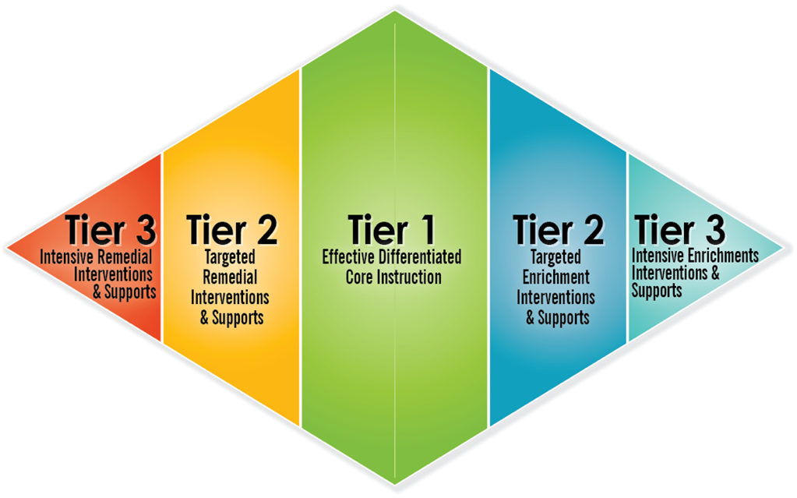

Standards of Student Behavior
A safe and positive learning environment is essential. Knowing and complying with the district’s expectations and procedures will support students in making positive choices. When students are disruptive or act inappropriately, they will be held accountable for their actions. When students do not follow the rules, school staff members are expected to respond appropriately and consistently.
Refer to the STRIDE Academy Student Handbook for information beyond the Code of Conduct:

This section of the Code of Conduct identifies the five levels of behavior infractions with examples of supports, interventions, and responses. These guidelines describe the various actions that may be taken when a behavior infraction occurs.

Interventions and responses will be used within the general guidelines of the five levels of the behavior matrix. Level one is the least severe and level five is the most severe. The format of this section includes the behavior infractions, their definitions, and the levels of each behavior. The dots in the matrix denote the level of behavior infractions but do not indicate which response will be taken at the administrative level. There shall be a logical relationship between the severity and frequency of the behavior infraction, the age of the student and the administrative action. School administrators will inform the parent/guardian of any student whose behavior is in serious conflict with established rules and procedures. Students and their families are responsible for working collaboratively with school staff to support the rules and procedures outlined in this Code of Conduct.

Unless otherwise noted, these policies apply to student behavior infractions occurring on any property owned or controlled by STRIDE Academy, occurring in connection with any activity sponsored by or associated with STRIDE Academy or off school premises to the extent that it substantially and materially disrupts student learning or the school environment.

Levels of Behavior, Intervention and Response

Level One (Setting Managed)

Behavior Definition
A level one behavior is a minor behavior infraction that is generally managed by the adult in the setting of the infraction. The staff’s response teaches correct, alternative behavior so students can learn and demonstrate safe and expected behaviors. Staff members are expected to employ a variety of teaching and management strategies.

Level One Behavior Interventions and Responses
- Select and implement interventions and responses that maintain the continuity of instruction or are least disruptive.
- Consider use of interventions from multiple categories as appropriate.
- Review and consider a student’s IEP or 504 Plan prior to implementing interventions and responses.
- Communicate with parents/guardians about recurrent behaviors and interventions.
- Document behavior in Skyward.

Intervention and Response Categories
Skills-Based Supports  - Re-teaching of expectations, procedures, and routines  - Increase positive feedback for  demonstration of expected behavior  - Reminder/Redirection on ways to ask for help or solve problems  - Reminder/Redirection on ways to manage emotions  - Reminder/Redirection of appropriate language  - Teacher/Student conference | Restorative Practices  - Brief individual skill coaching  - Responsibility Centered  Discipline Conference  - Repair/Mend relationship  - Fee restitution | Staff Actions  - Fidelity check of school-wide systems, structures and supports  - Review (classroom/non-classroom) behavior management plan including social skills teaching and reinforcement  - Classroom/Non-classroom supports  - Seat change, assigned seating  - Loss of related privileges  - Parent/Guardian notification  - Increase active supervision  - Confiscating items
Optional administrative actions that may result in removal from instruction
Note: A recurring behavior infraction may be treated as an infraction at a higher level

Level Two (Setting Managed)

Behavior Definition
A level two behavior is a repeated minor behavior infraction that is generally managed with a brief intervention by an adult in that setting. These actions aim to correct behavior by stressing the seriousness of the behavior while keeping the student in class. A level two behavior may include contact with support staff or an administrator and may result in a documented Office Discipline Referral (ODR).

Level Two Behavior Interventions and Responses
- Select and implement interventions and responses that maintain the continuity of instruction or are least disruptive.
- Consider the use of interventions from prior levels and multiple categories.
- Review and consider a student’s IEP or 504 Plan prior to implementing interventions and responses.
- Communicate with parents/guardians about the behaviors and interventions.
- Document behavior in Skyward.

Intervention and Response Categories
Skills-Based Supports  - Re-teaching routines, expectations, and procedures  - Increase positive feedback for demonstration of expected behavior  - Re-teaching ways to ask for help, solve problems, manage emotions  - Self-charting of behaviors  - Skill practice/role play  - Individual skill coaching  - Student contract  - School community service | Restorative Practices  - Guided conversations using restorative questions  - Responsibility Centered  Discipline Conference  - Restorative Circle for problem solving  - Community Service (as restitution)  - Reflective essay  - Restorative back-to-class plan | Staff/Administrative Actions  - Review student data to make an informed decision  - Develop a student skill plan  - Initiate behavior support plan  - Formalize check-in/out plan with adult  - Detention  - Loss of related privileges  - Assigned seating  - Time out of classroom: less than 15 minutes  - Consultation with colleagues  - Consider referral to MTSS team  - Parent/Guardian conference  - Increase active supervision
Optional administrative actions that may result in removal from instruction
Note: A recurring behavior infraction may be treated as an infraction at a higher level

Level Three (Office Managed)

Behavior Definition
A level three behavior is a major behavior infraction that disrupts the educational setting, targets others, and/or
impacts the safety of others. A level three behavior will result in an Office Behavior Intervention Referral and may result in removal from instruction for part of a day or an entire school day.

Level Three Behavior Interventions and Responses
- Select and implement interventions and responses that maintain the continuity of instruction or are least disruptive.
- Consider the use of interventions from prior levels and multiple categories.
- Review and consider a student’s IEP or 504 Plan prior to implementing interventions and responses.
- Communicate with parents/guardians about the behaviors and interventions.
- Document behavior in Skyward.

Intervention and Response Categories
Skills-Based Supports  - Individual or small group skill instruction  - Targeted instruction focused on the area of need  - Increase positive feedback for demonstration of targeted behaviors | Restorative Practices  - Restorative back-to-class plan  - Responsibility Centered  Discipline Conference  - Staff-led mediation  - Restitution for property incidents  - Restorative Circle | Staff/Administrative Actions  - Referral to student support team  - Loss of related privileges  - Alternative instruction  - Student-staff conference  - Change in classroom assignment/schedule  - Consult with School Resource Officer  - Loss of transportation (bus) privileges  - Development of a re-entry plan  - Parent/Guardian conference
Optional administrative actions that may result in removal from instruction
- In-school removal from instruction one (1) day or less
- Out-of-school dismissal from instruction one (1) day or less. Consider student’s age and understanding

Level Four (Office Managed)

Behavior Definition
A level four behavior is a major behavior infraction that significantly disrupts the educational setting, targets others, and/or impacts the safety of others and is distinguishable by its repetitiveness and/or severity. A level four behavior results in an Office Discipline Referral (ODR), may result in dismissal from school for one or more days, and may result in notification to law enforcement.

Level Four Behavior Interventions and Responses
- Select and implement interventions and responses that maintain the continuity of instruction or are least disruptive.
- Consider the use of interventions from prior levels and multiple categories.
- Review and consider a student’s IEP or 504 Plan prior to implementing interventions and responses.
- Communicate with parents/guardians about the behaviors and interventions.
- Document behavior in Skyward.

Intervention and Response Categories
Skills-Based Supports  - Increase positive feedback for demonstration of individualized behavior plan/goal  - Individualized skill instruction by licensed support staff  - Individual behavior support plan  - IEP/504 Plan Team consultation for potential changes | Restorative Practices  - Restorative transition back-to-class plan  - Neutral party mediation  - Family group conference  - Restitution for property incidents  - Restorative Circle | Staff/Administrative Actions  - Consultation with the School Resource Officer  - Refer to or review with student support team  - Referral to alcohol or drug counselor  - Loss of transportation (bus) privileges  - Consideration of alternative interim educational placement  - Development of a re-entry plan
Optional administrative actions that may result in removal from instruction
- Out-of-school dismissal from instruction not to exceed four (4) days. Consider student’s age and understanding

Level Five (Office Managed)

Behavior Definition
A level five behavior is a behavior infraction that involves removal of the student from the school environment because of the severity of the behavior. Interventions focus on maintaining the safety of the school community
and ending self-destructive and/or dangerous behavior. Level five behaviors are identified as expellable offenses.

Level Five Behavior Interventions and Responses
- Select and implement interventions and responses that maintain the continuity of instruction or are least disruptive.
- Consider the use of interventions from prior levels and multiple categories.
- Review and consider a student’s IEP or 504 Plan prior to implementing interventions and responses.
- Communicate with parents/guardians about the behaviors and interventions.
- Document behavior in Skyward.

Intervention and Response Categories
Skills-Based Supports  - Individual coaching by licensed staff  - Individual behavior support plan  - Increase positive feedback for demonstration of individualized behavior plan/goal | Restorative Practices  - Family group conference (may be as part of a move to a new setting) | Staff/Administrative Actions  - Consultation with student support team and Executive Director  - Development of a re-entry plan
Optional Administrative Actions that may result in removal from instruction
- Out-of-school dismissal from instruction five (5) or more days (ten (10) days if there is a recommendation for expulsion). Consider student’s age and understanding
- Possible recommendation for expulsion
- Consult with/refer to local law enforcement

Alphabetical Listing of Behaviors | 1 |  | 2 |  | 3 |  | 4 |  | 5
ACADEMIC DISHONESTY – AC0/AC1
Submitting another person’s work as your own, or allowing another person to use your work, including, but not limited to, cheating on a school assignment, plagiarism or using electronic devices or other technology to accomplish this end | ⬤ |  | ⬤ |  | ⬤
ALCOHOL – AL1
Possessing, using, distributing, or being under the influence of alcohol |  |  |  |  | ⬤ |  | ⬤ |  | ⬤
ARSON – AR1
The willful or malicious burning of school property |  |  |  |  |  |  | ⬤ |  | ⬤
ASSAULT-SEXUAL – AX1
Exhibiting conduct of a sexual or indecent nature toward another person that is accompanied by actual or threatened physical force or that induces fear, shame or mental suffering and can include the touching of another’s intimate parts, or forcing a person to touch any person’s intimate parts |  |  |  |  |  |  | ⬤ |  | ⬤
ASSAULT-PHYSICAL – AP1
An act done with intent to cause fear in another of immediate bodily harm or death; or the intentional infliction of, or attempt to inflict, bodily harm upon another; the threat to do bodily harm to another with present ability to carry out the threat |  |  |  |  |  |  | ⬤ |  | ⬤
BOMB THREAT – BT1
Any implied or active threat regarding incendiary or explosive device to cause property damage or injuries, whether or not such a device actually exists |  |  |  |  |  |  | ⬤ |  | ⬤
BULLYING – BL1
Repeated behavior by an individual or group that is intended to cause the victim, or would cause a reasonable person of the same age as the victim, to feel frightened, threatened, intimidated, humiliated, shamed, disgraced, ostracized or physically abused. Bullying can take place in several forms including, but not limited to, written, verbal or nonverbal threats or intimidating or threatening gestures |  |  |  |  | ⬤ |  | ⬤ |  | ⬤
CYBER-BULLYING – CB1
Bullying using technology or other electronic communication, including, but not limited to, transferring a sign, signal, writing, image, sound, or data, including posting on a social network Internet website or forum, transmitted through a computer, cell phone or other electronic device |  |  |  |  | ⬤ |  | ⬤ |  | ⬤
DEFIANCE – DF0
Engaging in brief or low-intensity failure to follow directions or talking back | ⬤ |  | ⬤
DEFIANCE/NON-COMPLIANCE – DF1
Repeated failure to follow directions and/or significant disruption of the learning environment |  |  |  | ⬤
DRESS CODE VIOLATION – DC0
Wearing clothing that does not fit within the dress code guidelines practiced by the school/district | ⬤ | ⬤
DRUGS, ILLEGAL – DI1
Using, possessing, or intending to sell a narcotic, drug or controlled substance, including, but not limited to, inhalants, marijuana and cocaine, drug paraphernalia and look-alike drugs and synthetics
Paraphernalia: Possessing any device used to consume drugs, including but not limited to, pipes, needles, clips, papers, pods, vapes, and any other containers or materials related to drugs or drug use |  |  |  | ⬤ |  | ⬤ |  | ⬤
Prescription: Possessing, except as prescribed by a physician and approved by a school nurse, or distributing prescription drugs |  |  |  | ⬤ |  | ⬤ |  | ⬤
Use/Possession: Possessing, using, distributing, or being under the influence of narcotics, drugs or other controlled substances or look alike substances |  |  |  | ⬤ |  | ⬤ |  | ⬤
FORGERY – FO0
Signing someone else’s name without their permission or knowledge | ⬤ | ⬤
GAMBLING – GA0
Playing a game of chance for stakes | ⬤ | ⬤
GANG ACTIVITY
Student misconduct that meets all of the following criteria: Belonging to or associating with a group of three or more people who band together under a common identifying symbol, sign, or name, and, while under the supervision of STRIDE Academy personnel, participating in a violation listed in this handbook to further an implicit or explicit goal of the gang/group
NOTE: Gang activity is documented in conjunction with a primary behavior infraction
HARASSMENT
Exhibiting unwelcome discriminatory behavior that has the purpose or effect of creating an environment that is intimidating, hostile or offensive with respect to that individual
Disability Harassment – HD1: Unwelcome discriminatory behavior based upon disability |  |  |  | ⬤ |  | ⬤ |  | ⬤
Ethnicity/National Origin Harassment – HE1: Unwelcome discriminatory behavior based upon ethnicity |  |  |  | ⬤ |  | ⬤ |  | ⬤
Gender/Sexual Harassment – HG1: Unwelcome discriminatory behavior based upon gender or gender identity and/or sexual advances, requests for sexual favors, and other verbal or physical harassment of a sexual nature |  |  |  | ⬤ |  | ⬤ |  | ⬤
Harassment Other – HO1: Unwelcome discriminatory behavior based upon familial status, public assistance status and/or age |  |  |  | ⬤ |  | ⬤ |  | ⬤
Racial Harassment – HC1: Unwelcome discriminatory behavior based upon race or color |  |  |  | ⬤ |  | ⬤ |  | ⬤
Religious Harassment – HR1: Unwelcome discriminatory behavior based upon religion or creed |  |  |  | ⬤ |  | ⬤ |  | ⬤
Sexual Orientation Harassment – HS1: Unwelcome discriminatory behavior based upon sexual orientation |  |  |  | ⬤ |  | ⬤ |  | ⬤
HAZING – HZ1
Committing a potentially harmful act against a student or coercing a student into committing such an act, in order for the student to be initiated into, or affiliated with, an organization or for any other purpose |  |  |  | ⬤ |  | ⬤ |  | ⬤
INAPPROPRIATE LANGUAGE – IL0/IL1
Use of language that is offensive to others, including but not limited to, profanity, obscenities, or any language that is disruptive to the learning environment; discriminatory language will be considered harassment | ⬤ | ⬤ |  | ⬤
LEFT GROUNDS – LG1
Leaving building/grounds without permission and returning during the day, including, but not limited to, student leaving campus to eat lunch and returning |  |  |  | ⬤ |  | ⬤
MAJOR SCHOOL DISRUPTION – MD1
Substantial non-compliance, failure to follow directions, and interruption of learning for self or others |  |  |  | ⬤ |  | ⬤ |  | ⬤
OVER-THE-COUNTER MEDICATIONS – OM0/OM1
Except as excluded by policy, possessing non-prescription medications while on school property
Possessing or using over-the-counter medications without permission |  | ⬤ |  | ⬤
Selling or distributing over-the-counter medications |  |  |  | ⬤ |  | ⬤ |  | ⬤
PARKING VIOLATION – PV0
Parking in an unauthorized area on school property or parking without a permit or permission |  | ⬤
PHYSICAL AGGRESSION – PA1
An intentional act of physical aggression toward staff or students with intent to harm |  |  |  | ⬤ |  | ⬤ |  | ⬤
PHYSICAL CONTACT – PC0/PC1
An act of physical contact toward students including rough housing, horseplay, public displays of affection and sexual acts | ⬤ | ⬤ |  | ⬤ |  | ⬤
PROPERTY MISUSE – PM0/PM1
Using an item or piece of equipment in a manner for which it was not intended, including but not limited to, damaging school property or the property of others | ⬤ | ⬤ |  | ⬤
RECKLESS DRIVING – RD1
Driving on district property in such a manner to endanger persons or property |  |  |  | ⬤ |  | ⬤
TEASING – TE0
A single occurrence of teasing or name calling with or without the intent to injure, degrade, disgrace or intimidate other individuals | ⬤ | ⬤
TECHNOLOGY MISUSE – TV0/TV1
Engaging in inappropriate use of a personal device, camera, computer or other electronic device; discriminatory use will be considered harassment | ⬤ | ⬤ |  | ⬤ |  | ⬤
THEFT—TH0/TH1
Intentionally using, taking or possessing another’s property without permission/authorization or with the intent to deprive the owner of his/her property including, but not limited to school supplies, food, clothing, electronics, etc. | ⬤ | ⬤ |  | ⬤ |  | ⬤
THREAT/INTIMIDATION – TI0/TI1
Conveying an intent to cause harm or violence through an oral, written, or physical threat, sign or act |  | ⬤ |  | ⬤ |  | ⬤ |  | ⬤
TOBACCO and TOBACCO-RELATED DEVICES – TB1
Possessing or using a tobacco-based, look-alike product or tobacco-related device, including, but not limited to, electronic cigarettes, packaging, storage, juice, pods, containers or possession of tobacco-related products such as a lighter or matches |  |  |  | ⬤ |  | ⬤
TRESPASSING – TP0/TP1
Being on school district property without permission during or after school hours or after being directed to leave, including, but not limited to, being on district property during a suspension or expulsion | ⬤ | ⬤ |  | ⬤ |  | ⬤
TRUANCY—TR0/TR1
Being absent from class or school without a lawful excuse
Skipping Class– SC0/SC1 Being absent from class without teacher authorization (i.e., student is in the building/on school grounds but not attending class) | ⬤ | ⬤ |  | ⬤
Tardiness– TA0/TA1 Arriving late to class or to school | ⬤ | ⬤ |  | ⬤
Unexcused Absence – TR0/TR1 Being absent from class or school without authorization (i.e., exceeding allowed number of absences, leaving school grounds without permission) |  | ⬤ |  | ⬤
Chronic Truancy – TR0/TR1 Continuing unauthorized absences  NOTE: Incidents of chronic truancy are referred to the County Truancy Intervention Specialist and necessitate the filing of a truancy petition/educational neglect with the County Attorney |  | ⬤ |  | ⬤
VANDALISM – VN0/VN1
Deliberate destruction of or damage to district or private property | ⬤ | ⬤ |  | ⬤ |  | ⬤ |  | ⬤
VERBAL ABUSE – VB0/VB1
The act of forcefully criticizing, insulting, or denouncing another person. Characterized by underlying anger and hostility, it is a destructive form of communication intended to harm the self-concept of the other person and produce negative emotions | ⬤ | ⬤ |  | ⬤
VERBAL AGGRESSION – VA0/VA1
Inappropriately using words directed toward another person, including but not limited to name-calling, profanity or other types of inappropriate terms to provoke conflict or physical harm | ⬤ | ⬤ |  | ⬤ |  | ⬤
WEAPON—WE1
Any firearm, whether loaded or unloaded, any device or instrument designed as a weapon or through its use capable of threatening or producing great bodily harm or death, or any device or instrument that is used to threaten or cause bodily harm or death and combustible or flammable liquids. For more detail, click this link: School Board Policy 501, Weapons Policy
Firearm: Possessing or using a device designed to be used as a weapon, from which is expelled a projectile by the force of explosion or force of combustion |  |  |  |  |  |  |  | ⬤
Other Weapon or Object, Not a Firearm: Possessing or using any device or instrument—including any non-conventional weapon—that, in the manner it is used or intended to be used, is calculated or likely to produce bodily harm or substantial bodily harm, or fear of any degree of bodily harm. (Other weapons include knives with blades under 2.5 inches, fake knives, look alike weapons, ammunition, etc.) |  |  |  | ⬤ |  | ⬤ |  | ⬤

Additional Information
Intervention Processes
All intervention actions will be processed pursuant to STRIDE Academy discipline policies, the requirements of the Minnesota Pupil Fair Dismissal Act and other applicable law.
- School staff will use support, responses and interventions in the Code of Conduct to respond to behavior infractions.
- Juvenile or criminal proceedings or consequences against the student do not preclude the school district from disciplining the student for violations of the Rights and Responsibilities Handbook or for other misconduct.
- Any student who violates a policy that has a potential consequence of suspension from school for more than one school day shall have an informal conference with a school administrator.
- If a student’s total days of removal from school exceeds ten (10) cumulative days in a school year, the school district shall make reasonable attempts to convene a meeting with the student and the student’s parent or guardian before subsequently removing the student from school.
- All students who violate a policy or rule that has the potential consequence of expulsion or exclusion will be given the opportunity to have a hearing in accordance with Minnesota law.
- See the Minnesota State High School League Official Handbook to determine the impact of administrative actions on student eligibility and participation in Minnesota State High School League activities.

Alternative Educational Services Procedures
When students are removed from class because of a behavior infraction, school staff must provide missed assignments and the opportunity to make up those assignments in a reasonable amount of time without penalty. * Students with Individualized Education Programs (IEPs) and 504 Plans have additional protections.

If a student is suspended for more than five (5) school days, the student is entitled to alternative educational services that will allow the student to progress toward meeting graduation requirements and the suspending administrator must provide the Executive Director with a reason for the longer suspension. Generally, STRIDE Academy provides alternative educational services according to the following schedule:

Length of Suspension | Services Provided | School Administrator or Designee Responsibility | Parent/Guardian Responsibility
Up to five (5) school days | Current classroom work and homework will be made available, if possible | Arrange for collection of classroom work and homework from teachers | Pick up classroom work and homework from school or arrange to have it mailed to home  Return completed work upon  student’s return to school
Six (6) to ten (10 )school days* | Current classroom work and  homework will be made available no later than the sixth school day of suspension | Arrange for collection of classroom work and homework from teachers | Pick up classroom work  and homework from school or arrange to have it mailed to home Return completed work to school administrator
Up to 15 school days (only pending expulsion, consideration of administrative transfer, or when student constitutes a substantial and immediate danger)* | Alternative education services must be arranged to begin no later than the 11th school day | Arrange for alternative education services as soon as a determination has been made to refer student for expulsion or transfer | Assist school administrator in establishing a schedule for the delivery of alternative education services

This schedule does not preclude school administrators from providing different alternative educational services that allow the student to progress toward meeting graduation requirements. Each suspension action may include a readmission plan. The readmission plan shall include, where appropriate, a provision for implementing alternative educational services upon readmission and may not be used to extend the current suspension.
The school administrator is responsible for ensuring that the school attempts to provide required alternative educational services. Families also have the responsibilities set forth above. Parents who have concerns about the school’s compliance with these procedures should contact the school administrator or Executive Director promptly.

Students with a Section 504 Plan
Students covered by Section 504 of the Rehabilitation Act of 1973 may be disciplined for behavior related to their disabilities, unless the discipline would result in a significant change of placement. A qualified student with a disability may not be suspended for more than ten cumulative school days without a manifestation determination conducted by the student’s 504 team.

Students with an Individualized Education Program (IEP)
When a student with a disability is dismissed for more than ten (10) days in a school year, is being considered for a 45-day unilateral placement, or before initiating any expulsion or exclusion, relevant members of the child’s IEP team and the child’s parent shall, consistent with federal law, conduct a manifestation determination meeting. That meeting must occur as soon as possible, but no more than ten days after the sixth consecutive day of suspension or when the tenth cumulative day of suspension has elapsed. The team will determine if the behavior is related to the student’s disability. The team may need to conduct a Functional Behavior Assessment and write a behavior intervention plan to support the student at school.
A dismissal for one (1) school day or less is a day of suspension if the student with a disability does not receive regular or special education instruction during that dismissal period. A student with a disability shall be provided alternative educational services to the extent a suspension exceeds five (5) consecutive school days.
Consistent with federal law, before initiating an expulsion or exclusion, the district, relevant members of the student’s IEP team, and the student’s parent shall determine whether the student’s behavior was caused by or had a direct and substantial relationship to the student’s disability and whether the student’s conduct was a direct result of a failure to implement the student’s IEP. When a student with a disability who has an IEP is excluded or expelled for misbehavior that is not a manifestation of the student’s disability, the district shall continue to provide special education and related services during the exclusion or expulsion. Minnesota Statute § 121A.43

 | IEP Team Meeting Required | Manifestation Determination Required | Functional Behavioral  Assessment Plan Required | Alternative Education  Services Required
Student removed for one school day or less | No* | No* | No* | No*
Student suspended for less than five consecutive school days | No* | No* | No* | No*
Student suspended for six OR MORE consecutive school days | Yes | Yes | No* | Yes
Student removed for 10 days in a school year | Yes | Yes | Yes | Yes, access to FAPE required
Student placed on in-school suspension | No** | No** | No** | No**
Student suspended from the bus | IEP specific*** | IEP  specific*** | IEP  specific*** | IEP  specific***
Parent requests a manifestation determination following any removal for disciplinary reasons. | Yes | Yes | No* | No*
*Unless the student has been removed 11 or more cumulative days in a school year. Minnesota Statute § 121A.43(a).
**In-school suspension is not considered a day of suspension for a student with a disability as long as the student continues to receive regular and special education services during the in-school suspension.
***If bus transportation is a part of the student’s IEP, a bus suspension would be treated as a removal unless the school provides transportation in some other way, because that transportation is necessary for the student to obtain access to the location where all other services will be delivered. If bus transportation is not a part of the student’s IEP, a bus suspension typically would not be a removal.

Glossary of Terms

Academic Dishonesty
Submitting another person’s work as your own, including but not limited to cheating on a school assignment, plagiarism or using electronic devices or other technology to accomplish this end

Active Supervision
A proactive approach for monitoring students in a given area by scanning, moving and interacting with students while providing positive feedback and effective error correction

Alcohol
Any liquid containing any amount of alcohol, including but not limited to non-alcoholic beer, wine, or spirits.
  - Possessing, distributing or selling alcohol
  - Being under the influence of alcohol

Arson
The willful or malicious burning of school property

Assault-Physical
An act done with intent to cause fear in another of immediate bodily harm or death; or the intentional infliction of, or attempt to inflict, bodily harm upon another.

Assault-Sexual
Exhibiting conduct of a sexual or indecent nature toward another person that is accompanied by actual or threatened physical force or that induces fear, shame or mental suffering

Bomb Threat
Threatening to detonate an incendiary or explosive device to cause property damage or injuries, whether or not such a device actually exists

Bullying
Repeated behavior by an individual or group that is intended to cause the victim, or would cause a reasonable person of the same age as the victim, to feel frightened, threatened, intimidated, humiliated, shamed, disgraced, ostracized or physically abused. Bullying can take place in several forms including, but not limited to, written, verbal or nonverbal threats or intimidating or threatening gestures

Community Service
Unpaid service for the benefit of the public that is performed by a student or students in lieu of, or in addition to, formal intervention

Cyber-Bullying

Bullying using technology or other electronic communication, including, but not limited to, transferring a sign, signal, writing, image, sound, or data, including posting on a social network Internet website or forum, transmitted through a computer, cell phone or other electronic device

Defiance
Engaging in brief or low-intensity failure to follow directions or talking back

Defiance /Non-Compliance
Repeated failure to follow directions and/or significant disruption of the learning environment

Dress Code Violation
Wearing clothing that does not fit within the dress code guidelines practiced by the school/district

Drugs, Illegal
Using, possessing, or intending to sell a narcotic, drug or controlled substance, including, but not limited to, inhalants, marijuana and cocaine, drug paraphernalia and look-alike drugs and synthetics
  - Paraphernalia: Possessing any device used to consume drugs, including but not limited to pipes, needles, clips, papers, pods, vapes, and any other containers or materials related to drugs
  - Prescription: Possessing, except as prescribed by a physician and approved by a school nurse, or distribution of prescription drugs
  - Use/Possession: Possessing, using, distributing, under the influence of narcotics, drugs or other controlled substances or look alike substances

Forgery
Signing someone else’s name without their permission or knowledge

Free Appropriate Public Education (FAPE)
An educational right of children with disabilities guaranteed by federal law

Functional Behavioral Assessment
A process for gathering information to understand the structure and function of a student’s behavior(s) in order to develop an effective and efficient behavioral support plan that teaches and encourages alternative behaviors

Gambling
Playing of a game of chance for stakes

Gang Activity
Student misconduct that meets all of the following criteria:
Belonging to or associating with a group of three or more people who band together under a common identifying symbol, sign, or name, and, while under the supervision of District 47 personnel, participating in a violation listed in this handbook to further an implicit or explicit goal of the gang/group

NOTE: Gang activity is documented in conjunction with a primary behavior infraction

Harassment
Exhibiting unwelcome discriminatory behavior that has the purpose or effect of creating an environment that is intimidating, hostile or offensive with respect to that individual
    - Disability Harassment: Unwelcome discriminatory behavior based upon disability
    - Ethnicity/National Origin Harassment: Unwelcome discriminatory behavior based upon ethnicity
    - Gender/Sexual Harassment: Unwelcome discriminatory behavior based upon gender or gender identity and/or sexual advances, requests for sexual favors, and other verbal or physical harassment of a sexual nature
    - Harassment Other: Unwelcome discriminatory behavior based upon familial status, public assistance status, and/or age
    - Racial Harassment: Unwelcome discriminatory behavior based upon race or color
    - Religious Harassment: Unwelcome discriminatory behavior based upon religion or creed
    - Sexual Orientation Harassment: Unwelcome discriminatory behavior based upon sexual orientation

Hazing
Committing a potentially harmful act against a student or coercing a student into committing such an act, in order for the student to be initiated into or affiliated with an organization or for any other purpose

Inappropriate Language

Use of language that is offensive to others, including but not limited to, profanity, obscenities, or any language that is disruptive to the learning environment

Left Grounds
Leaving building/grounds without permission and returning
during the day, including but not limited to student leaving closed campus to eat lunch and returning

Major School Disruption

Substantial non-compliance, failure to follow directions, and interruption of learning for self or others

Manifestation Determination
A process to determine if a student’s behavior infraction was or was not a manifestation of the student’s disability

Notice of Procedural Safeguards
A document describing the rights of a parent of a child with a disability and the procedures that safeguard those rights under state and federal special education law
Parking Violation
Parking in an unauthorized area on school property or parking without a permit or permission

Peer Mediation
A process that empowers students to learn to resolve disputes with one another

Physical Aggression
An intentional act of physical aggression toward staff or students with intent to harm

Physical Contact
An act of physical contact toward students including rough housing, horseplay, public displays of affection and sexual acts

Property Misuse
Using an item or piece of equipment in a manner for which it was not intended, including but not limited to, damaging or destructing school property or the property of others

Reasonable Person
A hypothetical, ordinary individual who exercises average care, skill, and judgment

Reckless Driving
Driving on district property in such a manner to endanger person or property

Restorative Circle
A community process for supporting those in conflict through a structured meeting that holds individuals accountable for their actions and addresses the needs of those who have been harmed

Restorative Practices
Interventions to hold students accountable for harm and teach
them the skills of prosocial behaviors in the context of community and relationships

School Resource Officers (SRO)
Sworn officers of our local police departments who work in partnership with school administrators to provide the safest learning environment possible. The SRO’s primary function is law enforcement

Teasing
A single occurrence of teasing or name calling with or without the intent to injure, degrade, disgrace, or intimidate other individuals

Technology Misuse
Engaging in inappropriate use of a personal device, camera, computer, or other electronic device.

Theft
Intentionally using, taking or possessing another’s property without permission or with the intent to deprive the owner of his/ her property
- Minor Theft: Taking or possessing another’s property without permission, including, but not limited to, school supplies, food, etc.
- Major Theft: Unauthorized taking or possessing the property of another, including but not limited to clothing, electronics, etc.
Threat/Intimidation
Conveying an intent to cause harm or violence through an oral, written, or physical threat, sign or act

Tobacco and Tobacco-Related Devices
Possessing or using a tobacco-based, look-alike product or tobacco
-related device, including, but not limited to, electronic cigarettes or possession of a tobacco-related product such as a lighter, matches, packaging, storage, juice, pods, or containers.

Trespassing
Being on school district property without permission during or after school hours or after being directed to leave, including but not limited to being on district property during a suspension or expulsion.

Truancy
Being absent from attendance at school without a lawful excuse
- Skipping Class—Being absent from class without authorization
- Unexcused Absence—Being absent from school without authorization
- Tardiness—Arriving late to school or to class
- Chronic Truancy—Continuing unauthorized absences to school or to class
NOTE: Incidents of chronic truancy will be referred to the
County Truancy Intervention Specialist and may necessitate the filing of a truancy petition/educational neglect with the county attorney.

Vandalism

Deliberate destruction of or damage to district or private property

Verbal Abuse
The act of forcefully criticizing, insulting, or denouncing another person. Characterized by underlying anger and hostility, it is a destructive form of communication intended to harm the self-concept of the other person and produce negative emotions.

Verbal Aggression
Inappropriately using words directed toward another person, including but not limited to name-calling, profanity or other types of inappropriate use of words to provoke conflict or harm.

Weapon
Any firearm, whether loaded or unloaded, any device or
instrument designed as a weapon or through its use capable of threatening or producing great bodily harm or death, or any device or instrument that is used to threaten or cause bodily harm or death and combustible or flammable liquids
- Dangerous Weapon Other Than A Firearm Possessing or using:
  - Any device or instrument designed as a weapon and capable of producing death or great bodily harm
  - Any device modified so that it may be used as a weapon and capable of producing death or great bodily harm
  - Any combustible or flammable liquid or other device or instrumentality that, in the manner it is used or intended to be used, is calculated or likely to produce death or great bodily harm
  - Any fire that is used to produce death or great bodily harm
  - Any knife with a blade equal to or greater than 2.5 inches in length
  - Any replica firearm, BB gun, or pellet gun
- Firearm – Possessing or using a device designed to be used as a weapon, from which is expelled a projectile by the force of explosion or force of combustion.
- Other Weapon or Object, not a Firearm– Possessing or using any device or instrument—including any non-conventional weapon—that, in the manner it is used or intended to be used, is calculated or likely to produce bodily harm or substantial bodily harm, or fear of any degree of bodily harm. (Other weapons include knives with blades under 2.5 inches, fake knives, look alike weapons, ammunition, etc.)

Resources and Assistance to Resolve Issues

STRIDE Academy does not discriminate on the basis of race, creed, sex, marital status, national origin, age, color, religion, ancestry, status with regard to public assistance, sexual or affectional orientation, familial status or disability. Inquiries regarding our non-discrimination policies should be directed as follows:

To report discrimination, harassment or other violations:
  - of employees - contact STRIDE Academy Human Rights Officer, 320-230-5340
  - of students - first contact the administrator of the school/program, if unresolved, call 320-230-5340 to report discrimination, including Title IX (sex discrimination) violations or violations of student human rights

Students with Disabilities STRIDE Academy Resources
  - Student Services/Special Education/504 Coordinator 320-230-5340

Non-STRIDE School Resources
  - MDE (Minnesota Department of Education):
651-582-5200
  - PACER (Parent Advocacy Coalition for Education Rights): 952-838-9000
