Adopted: MSBA/MASA Model Policy 504

Orig. 2022 (as Charter Policy)
Revised: Rev. 2023

504 STUDENT DRESS AND APPEARANCE

PLEASE NOTE: MINNESOTA SCHOOL DISTRICTS AND CHARTER SCHOOLS ARE
NOT REQUIRED TO REVISE THEIR DRESS CODE POLICIES AT THIS TIME.

For the past year, the Minnesota School Boards Association (MSBA) has engaged in a deep review of Model Policy 504—Student Dress and Appearance.

The updates offered below reflect the key goals of permitting students to engage in their First Amendment right to express themselves while maintaining a positive school environment in which learning is promoted and students are protected from harm.

In updating Model Policy 504, MSBA seeks to promote and support local discussion and decision-making. Alternative provisions are offered, such as on head wear and hats, in order to assist board members as they create a policy that best fits their schools and their communities.

As Minnesota charter schools review and revise their dress code policies, MSBA anticipates that it will learn valuable lessons that can be shared with other schools throughout the state. The revisions offered here are a starting point and are likely to be augmented in the future.

This model policy uses the term “dress code” to refer to the policy itself because of the longstanding practice and community familiarity with the term. A school board can choose to use a different term, such as “clothing,” to replace dress.

Minnesota school boards have considerable authority to decide whether to have a dress code policy at all. Boards can choose the provisions the policy contains. School boards might choose to retain their current dress code policy. Boards may opt to change some provisions and to keep others. Boards may include language that does not appear in Model Policy 504.

The Minnesota legislature passed two laws in 2023 that are relevant to dress codes. These changes are highlighted below.

School boards may choose to engage with students, staff, parents and guardians, and others to craft a dress code for the charter school.

In light of the many local decision points that a dress code invites, MSBA decided to not attempt to create a redline version that could be universal across the state.

I. PURPOSE

The purpose of this policy is to enhance the education of students by establishing expectations that support educational goals. Students and their families have the primary and joint responsibility for student clothing and appearance. Teachers and other charter school staff should exemplify and reinforce student clothing and appearance standards and help students develop an understanding of appropriate appearance in the school environment.

The school board is encouraged to draft a purpose statement that reflects the charter school’s mission and goals.

The dress code provisions offered below recognize that clothing is an expressive activity protected under the First Amendment. The policy seeks to promote fair treatment of all students and to reduce staff time spent monitoring student clothing. School boards may choose to adopt all, some, or none of the suggested provisions.

II. GENERAL STATEMENT OF POLICY

A. The policy of the charter school is to encourage students to be dressed suitably [or appropriately] for school activities and in keeping with community standards.

As school boards create a school dress code, they often encounter challenges related to subjective terms—such as appropriate, suitable, or community standards—that can be vague and can vary from one person’s interpretation to another. School boards may choose to provide more explicit provisions, such as are presented below.

B. A student’s clothing or appearance may not materially and substantially disrupt or interfere with the educational mission, school environment, classwork, or school activities. A student’s dress or appearance may not incite or contribute to substantial disorder or invasion of the rights of others or pose a threat to the health or safety of the student or others.

Unlike Paragraph A above, Paragraph B focuses upon potential effects upon learning, discipline, and safety as it balances students’ right to express themselves. The standards stated in Paragraph B draw upon the U.S. Supreme Court decision in Tinker v. Des Moines Independent Community School District and subsequent decisions (see Legal References below).

C. Students’ rights to choose their dress and appearance for school and school-related activities will be protected provided that the clothing:

1. does not injure people or damage property;

2. does not materially and substantially disrupt or interfere with the educational process or classwork;

3. does not interfere with the requirements of discipline in the operation of the school or school activities, materially disrupt classwork;

4. does not involve substantial disorder or invasion of the rights of others.

Such clothing includes, but is not limited to, the following:

1. Clothing for the weather.

2. Clothing that does not create a health or safety hazard.

3. Clothing for the activity (i.e., physical education or the classroom).

4. Footwear that does not present a safety hazard.

5. Headwear, including hats or head coverings, are allowed provided that it does not cover the student’s face to the extent that the student is not identifiable. Headgear must not interfere with the educational process. Hoodies must allow the face and ears to be visible from the front and sides and must not interfere with the line of sight to any student or staff including while the student wearing the hoodie is seated. Students may wear headgear for a medical or religious reason.

Across the nation, school boards have been encouraged to reconsider rules regarding hats and other headwear. In recent years, Minnesota charter schools have developed a range of policies regarding hats and related headgear. Some charter schools have chosen to maintain a prohibition. Others have created grade/building specific rules. Some boards have permitted hats while prohibiting hoods.

A school board could choose to direct school building-level administration to work with staff, students, and others to develop building-specific rules regarding headwear.

6. Hair, including but not limited to hair texture and hair styles such as braids, locks, and twists.

In 2023, the Minnesota legislature enacted the CROWN Act, which adds Subparagraph 6 to the protections under the Minnesota Human Rights Act.

C. Student clothing may not include the following:

1. Option 1: Students may not wear inappropriate clothing.

Option 2: Extremely brief garments and see-through garments may not be worn.

Option 3: Clothing must cover areas from one armpit across to the other armpit, down to approximately 3 to 4 inches in length on the upper thighs (see image).

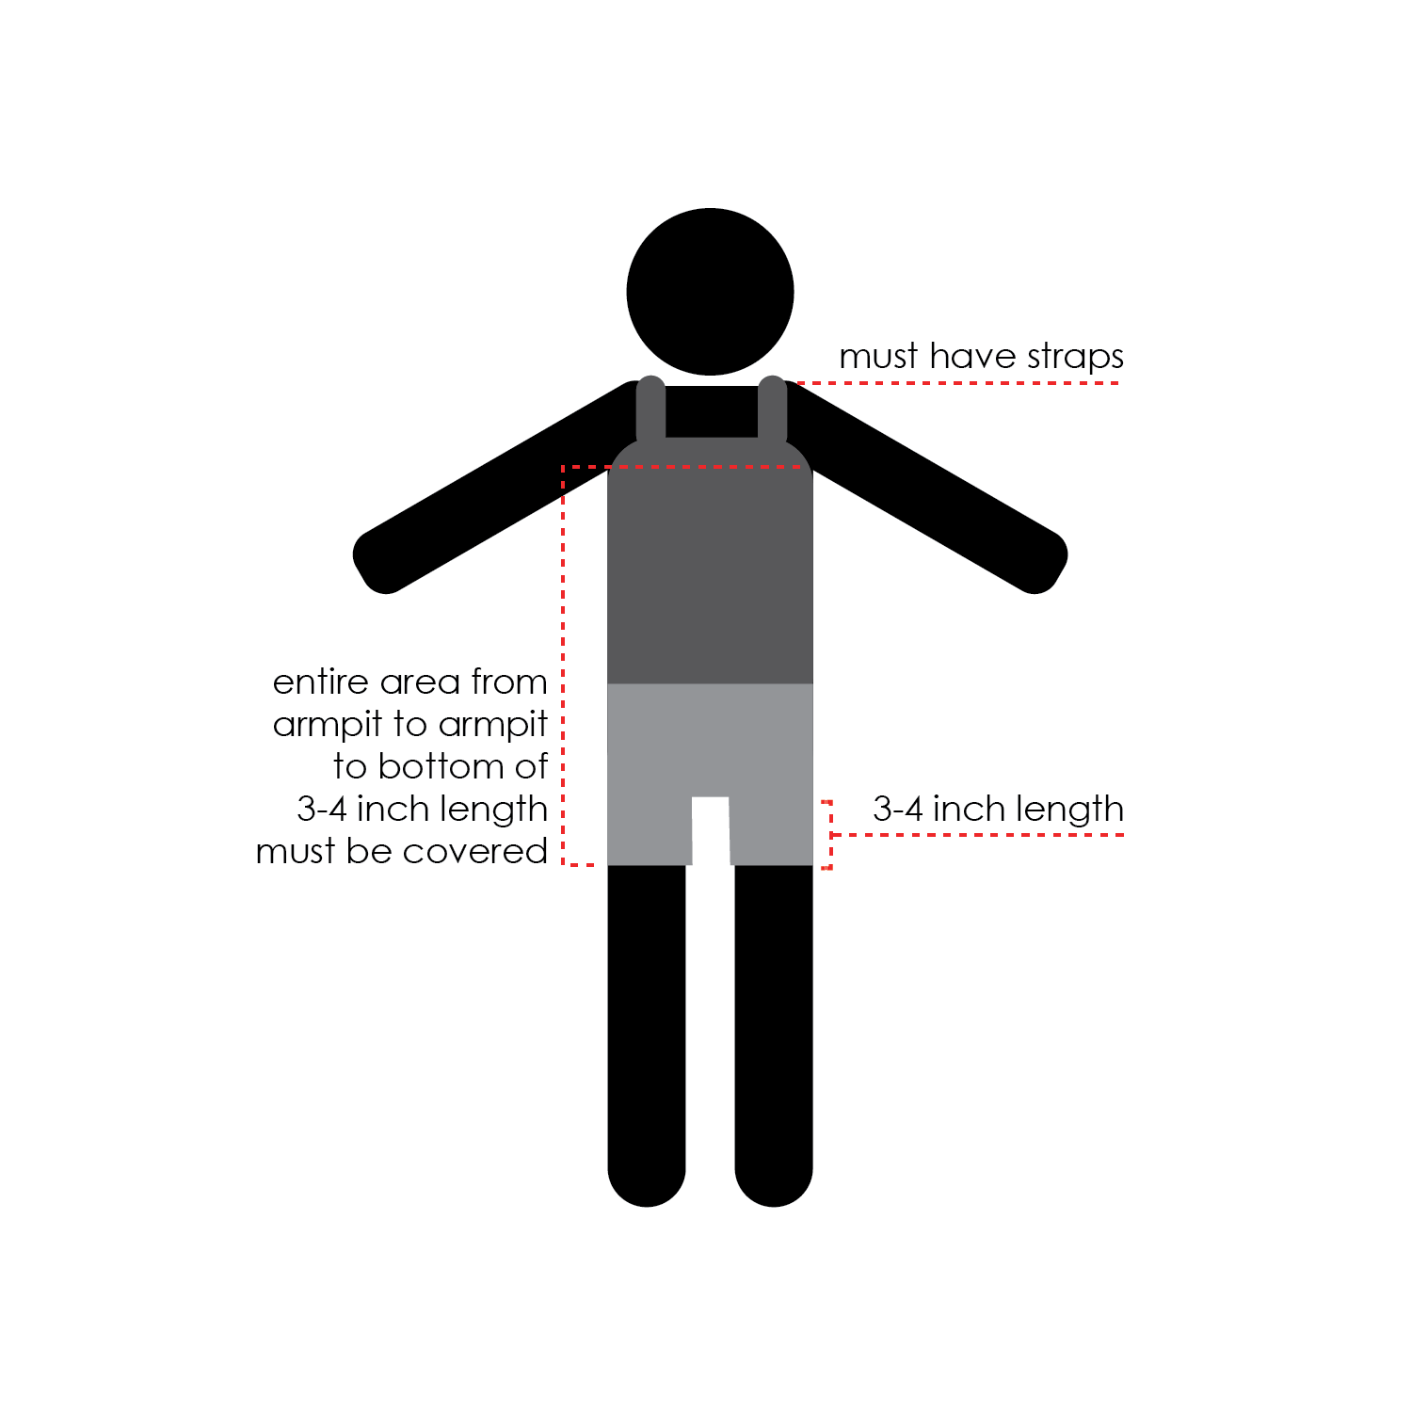

MSBA is grateful to the Roanoke County Public Schools (Virginia) for its permission to incorporate this image in Model Policy 504.

The previous Model Policy 504 prohibited “inappropriate” clothing and then presented a short list of examples. Creating a comprehensive, clear definition of “inappropriate” clothing presents significant challenges, as does reliance upon a small list of examples of “inappropriate” clothing.

MSBA encourages school boards to consider moving away from “appropriate” standards to an approach that focuses upon impacts upon other students and the educational process. A school board may decide to focus upon the prohibition upon clothing that “materially and substantially disrupts or interferes with” the educational process and related standards set out in Article II.B above rather than invoking a general ‘inappropriate’ standard.

MSBA understands that school boards may wish to establish expectations regarding clothing that covers one’s body. To this end, MSBA offers some examples a school board could adapt or adopt. Other options can be considered.

Subparagraphs 2-4 below could be retained regardless of how a school board chooses to proceed under Subparagraph 1.

2. Clothing (including emblems, badges, symbols, signs, words, objects or pictures on clothing or jewelry) bearing a message that is lewd, vulgar, obscene, libelous, or denigrates, harasses, discriminates against others on the basis of protected class status under the Minnesota Human Rights Act, or violates charter school policies prohibiting discrimination, violence, harassment, or other harmful activities.

Subparagraph 2 seeks to encourage understanding of the ways in which expression through clothing can communicate messages that create harm or a hostile learning environment for others.

3. Apparel promoting products or activities that are illegal for use by minors.

4. Communicating a message that is racist, sexist, or otherwise derogatory to a protected minority group, or approves, advances, or provokes any form of religious, racial, or sexual harassment and/or violence against other individuals as defined in Policy 413.

D. The intention of this policy is not to abridge the rights of students to express political, religious, philosophical, or similar opinions by wearing clothing on which such messages are stated. Such messages are acceptable as long as they are not lewd; vulgar; obscene; libelous; do not denigrate, harass, or discriminate against others on the basis of protected class status under the Minnesota Human Rights Act; or do not violate charter school policies prohibiting discrimination, bullying, violence, harassment, or other harmful activities.

Paragraph D confirms the right that students possess to express themselves within the general standards established in this policy. A school board could choose to combine this with Subparagraph 2 above.

III. PROCEDURES

A. Enforcement of a student dress code will be approached with careful consideration and sensitivity, with the goals of supporting students as they express themselves and pursue their full potential, of not shaming students, and of minimalizing loss of instructional time. When possible, dress code matters should be addressed privately with students, should seek to determine whether factors exist that impact the student’s ability to comply with the dress code, and should seek to address such issues.

B. When, in the reasonable judgment of the administration, (1) a student’s clothing or appearance may materially and substantially disrupt or interfere with the educational mission, school environment, classwork, or school activities; (2) may incite or contribute to substantial disorder or invasion of the rights of others; or (3) pose a threat to the health or safety of the student or others, the student will be directed to make modifications. Parents or guardians will be notified. Other consequences may be enforced in line with Policy 506 (Student Discipline).

C. The administration may recommend a form of clothing considered appropriate for a specific event and communicate the recommendation to students and parents or guardians. A school district or charter school must not prohibit an American Indian student from wearing American Indian regalia, Tribal regalia, or objects of cultural significance at a graduation ceremony.

In 2023, the Minnesota legislature enacted the second sentence in Paragraph C above.

D. Likewise, an organized student group may recommend a form of clothing for students considered appropriate for a specific event and bring such recommendation to the administration for approval.

Legal References: U. S. Const., amend. I
Minn. Stat. § 124D.792 (Graduation Ceremonies; Tribal Regalia and Objects of Cultural Significance)
Minn. Stat. § 363A.03, Subd. 36a (Definitions)
Tinker v. Des Moines Indep. Sch. Dist., 393 U.S. 503 (1969)
B.W.A. v. Farmington R-7 Sch. Dist., 554 F.3d 734 (8th Cir. 2009)
Lowry v. Watson Chapel Sch. Dist., 540 F.3d 752 (8th Cir. 2008)
Stephenson v. Davenport Cmty. Sch. Dist., 110 F.3d 1303 (8th Cir. 1997)
B.H. ex rel. Hawk v. Easton Area School Dist., 725 F.3d 293 (3rd Cir. 2013)
D.B. ex rel. Brogdon v. Lafon, 217 Fed. Appx. 518 (6th Cir. 2007)
Hardwick v. Heyward, 711 F.3d 426 (4th Cir. 2013)
Madrid v. Anthony, 510 F.Supp.2d 425 (S.D. Tex. 2007)
McIntire v. Bethel School, Indep. Sch. Dist. No. 3, 804 F.Supp. 1415 (W.D. Okla. 1992)
Hicks v. Halifax County Bd. of Educ., 93 F.Supp.2d 649 (E.D. N.C. 1999)
Olesen v. Bd. of Educ. of Sch. Dist. No. 228, 676 F.Supp. 820 (N.D. Ill. 1987)

Cross References: MSBA/MASA Model Policy 413 (Harassment and Violence)
MSBA/MASA Model Policy 506 (Student Discipline)
MSBA/MASA Model Policy 525 (Violence Prevention)

