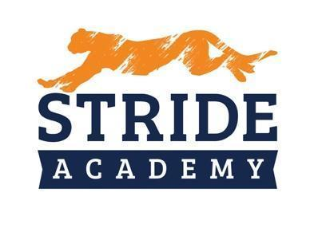

BOARD OF EDUCATION
STAFFING RECOMMENDATIONS

Administrator Making Recommendation: Angie Lichy

Department: Principal K-4 Date: 10/19/2022

Name of Candidate Recommended: Harlie Huelssman

☐ Resume Included (Yes) ☐ Social Media Screen (Yes)

☐ References Checked (Yes) ☐ Valid/Appropriate Licensure (Yes)

Position being filled: Health
- How did the vacancy occur? ☐ New Position ☐ Retirement. ☐ Resignation Other
- Who is being replaced? Aaron Eickhoff
- Has the position or vacancy been changed or modified? ☐Yes ☐ No How? NO

Salary
Experience: 3rd Year

Education: Masters K-6 Education Education Degree

Proposed Salary: $45,219 Plus $4,000 Signing Bonus ($2,000 this year and $2,000 2023-2024)
$500 referral bonus
OR
Proposed Hourly:

Extent of Employment (FTE): 1.0
OR
Number of Hours per Week:

Source of Funding:

General Fund: ☐ X Special Education: ☐ Other: ☐ (Identify)

Selection Process

Interview Team: Angie LIchy and Nathan Schwieters
Number of candidates interviewed 1 out of 1 applications

  - Internal
  - External X

Key issue(s) or qualities for decision: Previous Experience, strong classroom skills

