

ABC Review and Comment Submission

October 2025

The following Review and Comment Submission was approved by the STRIDE Academy school board on October 23, 2025. This submission has been developed to seek a positive review from the Minnesota Department of Education so the STRIDE Academy Building Company can acquire the school site located at 3701 33rd St. South St. Cloud, Minnesota, to meet growing demand and the needs of current and future learners at STRIDE Academy.

October 24, 2025

Commissioner Willie Jett
Minnesota Department of Education
400 NE Stinson Boulevard
Minneapolis, MN 55413

RE: Review and Comment Submittal for STRIDE Academy, a Minnesota Public Charter School

Dear Commissioner Mueller:

Pursuant to M.S. 123.71, the STRIDE Academy Board of Directors, the STRIDE Academy Building Company, and the Director of STRIDE Academy are pleased to submit this Review and Comment document for action by the Minnesota Department of Education.

STRIDE Academy is a K-8 public charter school that currently serves 841 students in St. Cloud, Minnesota at two school sites. 449 Kindergarten – 4th grade students are served at the educational campus at 3241 Oakham Lane St. Cloud, MN, which is owned by STRIDE Academy Building Company. 392 5th – 8th grade and online students are served at the educational campus at 3701 33rd St. South St. Cloud, which is owned by a third-party and leased to STRIDE Academy. The two sites are 1 mile apart from each other.

The student population consists of 93% students of color, 84% of which qualify for free and reduced lunches, and 58% of which are Multilingual Learners. STRIDE Academy is currently completing its twentieth year of operation and is authorized by Pillsbury United Communities

In 2016, STRIDE Academy formed an affiliated building company and purchased and improved the school property at 3241 Oakham Lane St. Cloud, Minnesota. In 2022, STRIDE Academy Building Company acquired two adjacent parcels and then installed a turf field on the acquired land in 2024 to meet outdoor play space needs. In May of 2025, STRIDE Academy entered into a lease agreement for the educational campus at 3701 33rd St. South. St. Cloud, MN and now serves 5th-8th grade students at the site in the 2025-26 school year. The lease agreement includes a purchase option which must be exercised on January 10th, 2026.

STRIDE Academy Building Company seeks to acquire the 3701 33rd St. South St. Cloud, MN campus to meet growing demand and to support district enrollment growth to 1,537 PreK-12 students by FY31. While only 1 mile apart, the acquisition provides long-term separation of elementary and secondary programming, provides open classrooms for PreK expansion at the Oakham Lane campus, and allows for expansion to high school grades within the existing 33rd St. facility. The 33rd St. campus meets STRIDE Academy’s long-term programming needs as-is, with minimal improvements necessary. At the time of acquisition, STRIDE Academy Building Company will improve two bathrooms, provide corridor access to the gymnasium, improve administrative office spaces at the main entry, resurface the parking lot, and complete identified maintenance and repairs to the existing HVAC system.

The total project cost is estimated at $21,260,784 which will be financed using additional tax-exempt bonds. Approximately $18,020,000 will be used for property acquisition and due diligence, $675,000 will be used to complete renovations and site improvements, $1,571,889 will be used for debt service reserve, and the remainder will be used to pay for the transaction, including design costs, legal fees, and financing costs. TenSquare is providing development management and consulting.

STRIDE Academy is in good standing with its trustee and investors. The financial health of the school and the size and scope of the new project meet the additional-indebtedness requirements within the exiting bond covenants.

This review and comment submittal to MDE seeks to allow the STRIDE Academy Building Company to secure additional tax-exempt bonds to finance acquisition and renovations at 3701 33rd St. South in St. Cloud, MN.

Since STRIDE Academy is a Minnesota public charter school, this project does not require voter approval through a bond referendum election. The STRIDE Academy Board of Directors approved this Review and Comment document to be submitted to the Commissioner of Education at its October 23, 2025 school board meeting.

Thank you for the opportunity to present STRIDE Academy’s facility plan for your review and comment. Should you have any questions, please free to call or email me at your convenience.

Sincerely,

Eric Skanson
Executive Director
STRIDE Academy

eskanson@strideacademy.org
320-492-3462

STRIDE Academy Review and Comment Submission Information

A school board proposing projects requiring review and comment shall submit to the commissioner a proposal containing the following information:

- The geographic area and population to be served
STRIDE Academy is an open enrollment public charter school currently serving students in grades kindergarten through 8th grade. The school’s two sites are currently located in St. Cloud and serve families that live in St. Cloud as well as surrounding communities of Sartell, Sauk Rapids, St. Joseph, Waite Park, Foley, Rice, Richmond, South Haven, and St. Augusta.

The map below shows where the school’s families currently reside.

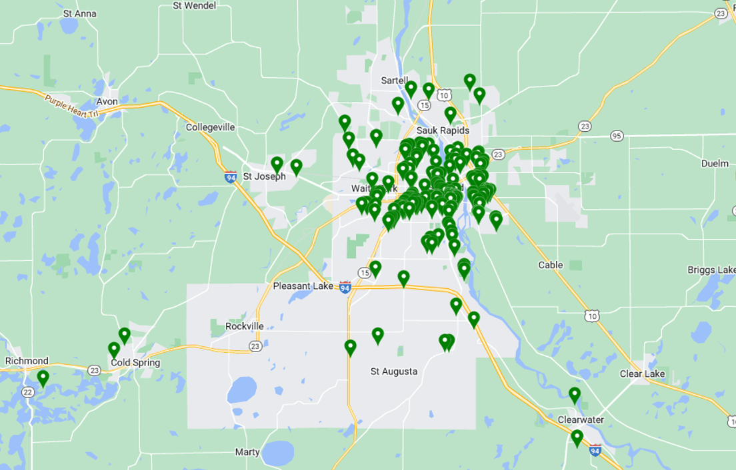

The map below shows the close proximity of the two school locations

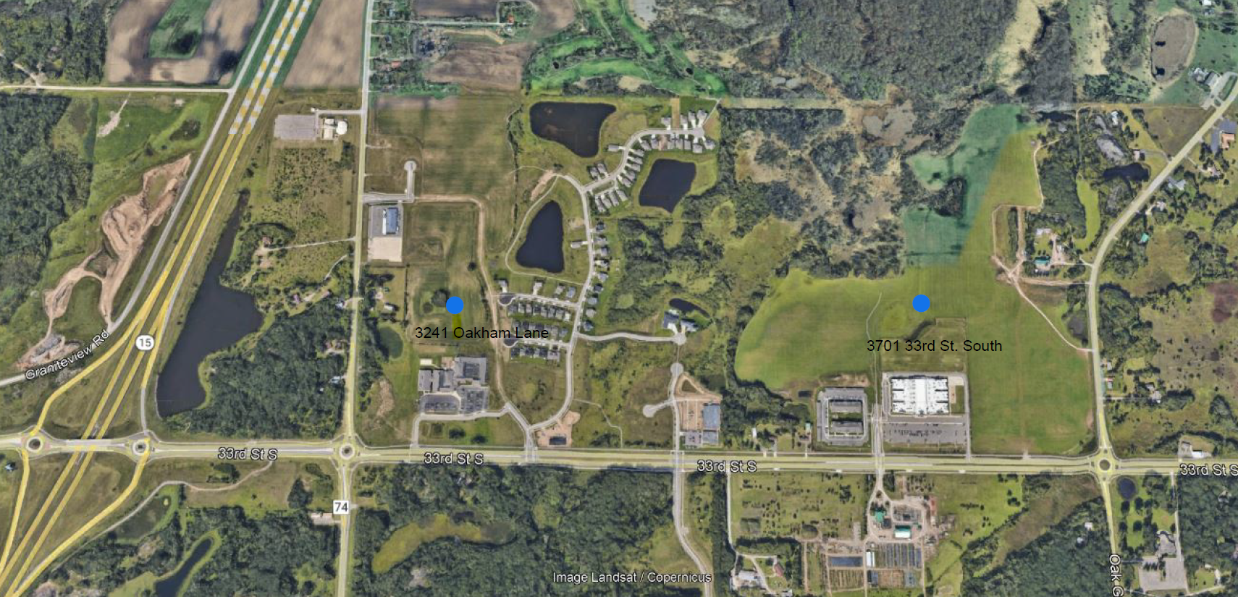
Student Enrollment
The following tables provide historical (as of October 1 of each school year) and projected enrollment information.

- Grade -specific preschool through grade 12 enrollment for the past five years

STRIDE Academy Historical Enrollment by Grade and Year,

FY 2021- FY 2025
School Year | K | 1 | 2 | 3 | 4 | 5 | 6 | 7 | 8 | Total
2020-21 | 43 | 53 | 52 | 53 | 65 | 61 | 47 | 44 | 38 | 456
2021-22 | 57 | 58 | 56 | 66 | 63 | 71 | 64 | 46 | 44 | 525
2022-23 | 45 | 57 | 65 | 64 | 71 | 70 | 72 | 55 | 45 | 544
2023-24 | 65 | 54 | 64 | 68 | 61 | 65 | 69 | 74 | 68 | 588
2024-25 | 43 | 56 | 57 | 69 | 69 | 59 | 72 | 70 | 74 | 569

- Grade-specific student enrollment projections for five years beyond the current year

STRIDE Academy Enrollment Count and Projections

FY 2023 - FY 2028

School Year | PK | K | 1 | 2 | 3 | 4 | 5 | 6 | 7 | 8 | 9 | 10 | 11 | 12 | Online | Total
2025-26* |  | 86 | 75 | 98 | 92 | 98 | 108 | 97 | 95 | 75 |  |  |  |  | 17 | 841
2026-27 |  | 90 | 100 | 80 | 105 | 95 | 105 | 110 | 105 | 100 |  |  |  |  | 22 | 912
2027-28 | 30 | 90 | 95 | 105 | 85 | 110 | 100 | 105 | 115 | 110 | 110 |  |  |  | 47 | 1102
2028-29 | 30 | 90 | 95 | 100 | 110 | 95 | 115 | 105 | 110 | 120 | 115 | 115 |  |  | 58 | 1258
2029-30 | 30 | 90 | 95 | 105 | 105 | 115 | 100 | 120 | 110 | 115 | 120 | 120 | 120 |  | 62 | 1407
2030-31 | 30 | 90 | 95 | 100 | 110 | 110 | 120 | 105 | 120 | 115 | 120 | 120 | 120 | 120 | 62 | 1537

* Current Enrollment October 17, 2025

A list of existing facilities by year constructed
- By year constructed with subsequent building additions identified by age and square footage

STRIDE Elementary - 3241 Oakham Lane St. Cloud, MN

The STRIDE Academy elementary school located at 3241 Oakham Lane is a single-story building. The current building was originally built in 2010 providing 20,354 square feet. Three subsequent renovation phases have occurred in 2012 (6,984 additional sf), 2013 (5112 additional sf), and 2016 (39,757 additional sf). The current total square ft of the building is 72,207.

STRIDE Middle and High School – 3701 33rd St. South St. Cloud, MN

The STRIDE Academy middle school located at 3701 33rd St. South is a single-story campus. The current building was built in 2015 and 87,000 square feet.

- Their uses

The 3241 Oakham building is used as a K-4 elementary school. The 3701 33rd St. South building is used as a K-5 middle school.

- An assessment of the extent to which alternate facilities are available within the school district boundaries

Close geographic proximity of any strategic grade level expansion has been a priority of STRIDE Academy. In 2024, STRIDE Academy explored a school expansion project at the 3241 Oakham Lane campus to provide a contiguous building addition and play space accessible to students. Ultimately, the building addition was not financed or completed but STRIDE Academy did prioritize and complete turf field improvements at the site.

Upon the closure of another charter school, the 3701 33rd St. South property became available for lease with a purchase option. The close 1 mile proximity of this facility to STRIDE Academy’s elementary school campus makes this site ideal for the current STRIDE Academy middle school and for future high school expansion.

Alternate facilities that are this close and are already built to suit are not available.

- And in adjacent school districts
Close geographic proximity of STRIDE Academy school facilities is a priority. An expansion in another district would not be workable or meet the needs of the STRIDE Academy community.

- A list of specific deficiencies of the facility

- Demonstrating the need for a new or renovated facility to be provided

Since the acquisition of the 3241 Oakham building in 2016, STRIDE Academy has seen consistent growth in family demand and student retention, reaching capacity and serving 569 students in grades K-8 in 2024-25. In 2025-26, STRIDE Academy now serves 841 students at two school sites. 449 Kindergarten – 4th grade students are served at 3241 Oakham Lane St. Cloud, MN. 392 5th – 8th grade and online students are served at 3701 33rd St. South. A two-site district model benefits STRIDE Academy’ school services at both sites in the long term.

The 3241 Oakham Lane elementary school now has classroom space to accommodate Pre-Kindergarten programming, an ongoing community need. Additionally, elementary specialist teachers now have dedicated classrooms, ELL/SPED spaces are returned for use, food service delivery is more efficient, and physician education programming is better scheduled now that the building better meets enrollment capacity.

Given growing enrollment demand, STRIDE Academy has developed a strategic plan to grow from 4 sections to 5 sections per grade, to add PreK in 2027-28, and to add high school grades starting with 9th grade in 2027-28.

The lease agreement in 2025-26 for the 33rd St. site has allowed STRIDE Academy to immediately realize a strong foundation for strategic growth as demonstrated by district enrollment growth from 569 students in FY25 to 841 current students in FY26. The 33rd St. site is already built-to-suit to meet STRIDE Academy’s strategic growth plan to serve middle school students and to expand to high school at that location. The Oakham Lane campus cannot accommodate the strategic growth plan to 1,537 students. A long-term solution to maintain two sites is necessary.

- The process used to determine the deficiencies, included completed facilities studies and facility committee findings/recommendations

The STRIDE Academy board has consistently evaluated growth options and has taken on measured growth initiatives when appropriate. As noted above, in 2022, STRIDE Academy Building Company acquired two adjacent parcels and then installed a turf field on the acquired land in 2024 to meet outdoor play space needs. During that time the STRIDE Academy school board and administration engaged in a strategic planning process to not just address play space improvements, but to also evaluate enrollment growth and expansion. STRIDE engaged DSGW Architecture to complete a space utilization assessment, Braun Intertec to complete a Property Condition Assessment of the Oakham Lane property, and TenSquare as development manager to assess the feasibility of the project. Working with school administration and board on enrollment projections, concept plans were developed to assess building addition needs for expansion.

While the 2024 expansion at the Oakham Lane site was not financed or completed, the work clarified STRIDE’s long term enrollment objectives and facility needs. When Athlos Academy announced its closure in March 2025, STRIDE Academy was well prepared to implement its strategic growth and could immediately support displaced families.

In May of 2025 STRIDE Academy entered into a lease agreement for the educational campus at 3701 33rd St. South. St. Cloud, MN and now serves 392 5th-8th grade students at the site in the 2025-26 school year. The lease agreement includes a purchase option which must be exercised on January 10th, 2026. STRIDE immediately engaged Braun Intertec to complete a Property Condition Assessment of the 33rd St. South property, engaged TenSquare as development manager and municipal advisor to support the lease and feasibility assessment of acquiring the facility. Yale Mechanical has been engaged to evaluate HVAC needs and DSGW Architecture has been engaged to provide design options to meet minor interior programmatic renovations.

Working with its contracted vendors, STRIDE identified several building deficiencies that have been resolved by the property owner, prior to STRIDE’s occupancy. These completed improvements in summer 2025 included roof repairs, brick repairs, EIFS exterior wall repairs, water-heater replacement, interior wall repairs, and HVAC/roof top unit repairs.

As part of the acquisition project, STRIDE Academy Building Company will provide further HVAC repairs and modernization, the parking lot will be resurfaced, two bathrooms will be redesigned, a new corridor access to the gym will be provided, and improvements will be made to administrative office spaces.

- A list of identified deficiencies that will not be addressed by the proposed projects

Once this project is completed, we do not believe there will be any identified deficiencies at either STRIDE Academy facility.

- A list of specific benefits that the new or renovated facility and/or site will provide to students, teachers, and community users served by the facility

- 2nd STRIDE Academy facility owned by STRIDE Academy Building Company supporting 940 students in grades 5 – 12.
- Long-term ownership of a facility for middle school and high school STRIDE Academy students that is only 1 mile from the STRIDE Academy elementary school location
- Close proximity of schools will benefit enrollment, transportation, programmatic alignment, and coordination between campuses
- 87,000 square foot facility that allows measured matriculated student growth each year.
- 50 classrooms and 12 breakout spaces providing core content, dedicated specialist spaces, and ELL/SPED spaces, to support the range of middle school and high school programming.
- Dedicated cafeteria, high school regulation basketball court, indoor turf athletic field, and administrative spaces.
- Outdoor grass playfields and playground

- Improved bathroom spaces and corridor access to gym

- Improved parking lot resurface to support arrival/drop off and student/staff parking.

- A description of the project including:

- Specifications of the site and outdoor space acreage

The newly acquired site at 3701 33rd St. South is 554,438 square feet, a 12.73 acre parcel. The building is approximately 87,000 square ft or 2 acres.

The site includes 202 regular parking stalls, 6 handicap accessible stalls, and 14 bus stalls. Outdoor activity spaces includes a 200,550 sf athletic playfield, a 4,825 sf playground with additional grass play space, an outdoor basketball court, and operational amenities such as trash enclosure and motorized safety gates.

The 3241 Oakham Lane site is 12.75 total acres and will not undergo any development at this time.

3701 Site Image:

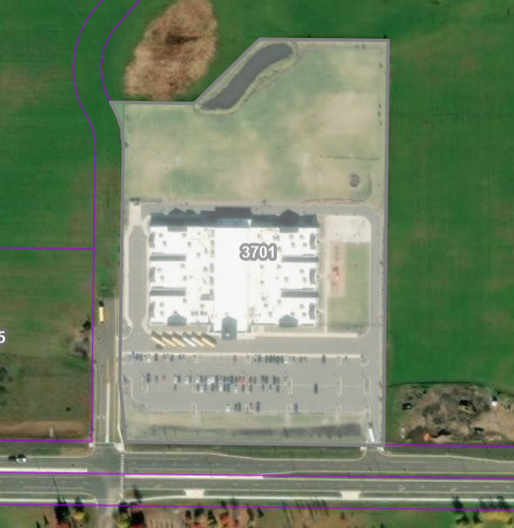
- Square footage allocations for classrooms, laboratories and support spaces

- Office and Admin Spaces 100 - 300 sf
- 42 Core Classrooms: 460 sf each
- Gymnasium & Indoor Turf field 16,657 sf
- 2 Science Labs 460 sf each
- 2 Art Classrooms 972 sf each
- 2 Computer/Tech Labs 972 sf each
- Music Room 940 sf
- Music Room/Stage 500 sf
- 12 Pull-out/ELL/SPED spaces 130-300 sf each
- Serving Kitchen and Cafeteria 4,025 sf

Facility schematics, space configurations, and square footage allocations are provided in Attachment 2.

- Estimated expenditures for major portions of the project

Uses of Financing
Property Acquisition and Due Diligence | $ 18,020,000
Improvements - Hard Costs | $ 675,000
Soft Costs (Including Commissions) | $ 533,000
Capitalized Interest | $ 150,895
Debt Service Reserve | $ 1,571,889
Project Contingency | $ 100,000
Development Consultant Fees | $ 210,000
Total Project Costs | $ 21,260,784

Estimated changes in facilities operating costs

We estimate the $87,000 square feet facility will cost $4 per square feet in operating costs for an increase in operational costs of $348,000.

- Dates the project will begin and be completed

The planned closing date for the transaction is April 1, 2026. STRIDE Academy currently leases the property and occupancy will be maintained during the limited renovations that take place in the summer of 2026.

- A specification of the source of project financing including

- Applicable statutory citations

- The schedules for the date for a bond issue or school board action

- A schedule of payment, including debt service equalization aid

- The effect of the bond issues on local property taxes by property class and valuation

By law charter schools cannot own their own facilities, nor can they levy taxes or secure bond financing to buy property and build schools. Charter schools may work with affiliated nonprofit building corporations (“ABCs”) or other nonprofit entities that own and incur debt obligations for facilities on the behalf of charter schools. Thus, it is the ABC, or the third party and not the school who is obligated to pay the debt on the property and facility. STRIDE Academy Building Company has been formed solely to own and lease the properties for STRIDE Academy’s use. The two parties will enter into an amendment of the existing lease agreement at the 3701 33rd St. South site to be signed prior to closing of the additional bond financing.

STRIDE Academy Building Company plans to issue Tax Exempt Bonds ($19,388,895) using the City of St. Cloud as the bond issuer. The bonds will be issued and sold with the cooperation Raymond James & Associates Inc., an experienced bond underwriter, that will manage the bond issuing process and will market and sell the bonds to investors. There is no financial risk to the City of St. Cloud or the State of Minnesota. STRIDE Academy Building Company plans to issue the Tax Exempt Bonds by April 1, 2026. The sources and uses of funds are detailed below with the proceeds of financing to be used for the acquisition and further development of the 3701 33rd St. South property by STRIDE Academy Building Company for continued use as a permanent home for STRIDE Academy.

STRIDE Academy Building Company Project Sources and Uses with Tax Exempt Bond Financing

Sources of Financing
Senior Financing (Additional Tax-Exempt Bonds) | $ 19,388,895
Subordinated Debt (NA) | $ -
Long-Term Financing (taxable bonds) | $ 300,000
Debt Service Reserve | $ 1,571,889
Equity (ABC) | $ -
Total Project Financing | $ 21,260,784

Uses of Financing
Property Acquisition and Due Diligence | $ 18,020,000
Improvements - Hard Costs | $ 675,000
Soft Costs (Including Commissions) | $ 533,000
Capitalized Interest | $ 150,895
Debt Service Reserve | $ 1,571,889
Project Contingency | $ 100,000
Development Consultant Fees | $ 210,000
Total Project Costs | $ 21,260,784

This project will have no impact on local property taxes, The property is currently tax exempt.

A 5-year STRIDE Academy budget projection is included as Attachment 3. The bonds are structured as 40-year fixed rate bonds. The schedule of debt service payments is included in Attachment 4.

- Documentation obligating the school district and contractors to comply with the following items:

- Minnesota Statutes, section 471.345 governing municipal contracts
- Sustainable design
- School facility commissioning under Minnesota Statutes, section 123B.72, certifying the plans and designs for heating, ventilating, air conditioning and air filtration for an extensively renovated or new facility meet or exceed current code standards, including American Society of Heating, Refrigerating and Air-Conditioning Engineers (ASHRAE) air filtration Standard 52.1
- American National Standards Institute (ANSI) acoustical performance criteria, design requirements and guidelines for schools on maximum background noise levels and reverberation times
- State fire code
- Minnesota Statutes, chapter 326B governing building codes
- Consultation with affected government units about the impact of the project on utilities, roads, sewers, sidewalks, retention ponds, school bus and automobile traffic, access to mass transit and safe access for pedestrians and cyclists

Attachment 1 provides signed documentation obligating STRIDE Academy and its contractors to comply with Minnesota Statute 471.345, Minnesota Statute 123B.72 and Minnesota Statute chapter 326B throughout any construction project and maintenance of documentation showing compliance with these items upon and subsequent to project completion.

Attachment 1
Review and Comment
Section #6 Documentation
(as amended by the 2014 Legislature)

The current facility is functioning and occupied by STRIDE Academy. For any contracted activities on the purchased land, STRIDE Academy ABC will cause its contractors to comply with items (i) to (vii) in planning and executing the development:

(i) The school district will be in compliance with Minnesota Statute 471.345 governing municipal contracts issued for this Facility;

(ii) The school district and the architects will include elements of sustainable design for this Facility;

(iii) If the Facility installs or modifies facility mechanical systems, the school district,
architect/engineers and contractors will be in compliance with school facility commissioning under Minnesota Statute 123B.72 certifying the plans and designs for the heating, ventilating, air conditioning, and air filtration for an extensively renovated or new facility meet or exceed current code standards, including the ASHRAE air filtration standard 52.1;

(iv) If the Facility creates or modifies interior spaces, the district, architects/engineers and relevant contractors have considered the American National Standards Institute Acoustical Performance Criteria, Design Requirements and Guidelines for Schools on maximum background noise level and reverberation times;

(v) The Facility will be in compliance with Minnesota State Fire Code;

(vi) The Facility will be in compliance with Minnesota Statute chapter 326B governing
building codes; and

(vii) The school district and the architects/engineers have been in consultation with
affected government units about the impact of the Facility on utilities, roads, sewers, sidewalks, retention ponds, school bus and automobile traffic, access to mass transit, and safe access for pedestrians and cyclists. The school district and architect/engineers will maintain documentation showing compliance with these items upon and subsequent to Facility completion.

Executive Director Signature: _____________________________ Date ____________
Board Chair Signature: ___________________________________ Date ____________

Attachment #2
Review and Comment
Facility schematics, space configurations, and square footage allocations

Attachment #3
Review and Comment
Long Range Budget Projection

See attached

Attachment #4
Schedule of Debt Service Payments

See attached

