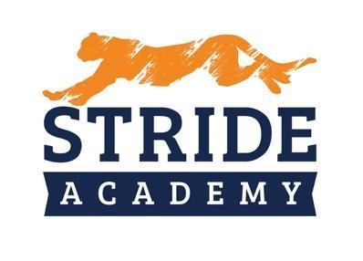

BOARD OF EDUCATION
STAFFING RECOMMENDATIONS

Administrator Making Recommendation: Angie Lichy

Department: Principal K-4 Date: 11/7/2022

Name of Candidate Recommended:

☐ Resume Included (Yes) ☐ Social Media Screen (Yes)

☐ References Checked (Yes) ☐ Valid/Appropriate Licensure Graduates 12.14.2022(Yes)

Position
- Position being filled: Grade 4
- How did the vacancy occur? X☐ New Position ☐ Retirement. ☐ Resignation
- Who is being replaced? NEW
- Has the position or vacancy been changed or modified? ☐Yes ☐ No How?

Salary
Experience: First Year Teacher graduates with degree 12/14/2022

Education:

Proposed Salary: $43,219 PRORATED Hiring Bonus $2,000 Grace Cote $500 referral bonus
OR
Proposed Hourly:

Extent of Employment (FTE): 1.0
OR
Number of Hours per Week:

Source of Funding:

General Fund: ☐ X Special Education: ☐ Other: ☐ (Identify)

Selection Process

Interview Team: Angie LIchy and Nathan Schwieters
Number of candidates interviewed 1 out of 1 applications

  - Internal
  - External

Key issue(s) or qualities for decision: Interviewed well, Grace Cote Student Teacher

