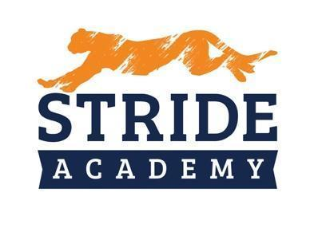

BOARD OF EDUCATION
STAFFING RECOMMENDATIONS

Administrator Making Recommendation: Angie Lichy

Department: Principal K-4 Date: 12/12/2022

Name of Candidate Recommended: Krystiana M Connelly

☐ Resume Included (Yes) ☐ Social Media Screen (Yes)

☐ References Checked (Yes) ☐ Valid/Appropriate Licensure (Yes)

Position
- Position being filled: ART
- How did the vacancy occur? ☐ New Position ☐ Retirement. ☐ X Resignation
- Who is being replaced? New
- Has the position or vacancy been changed or modified? ☐Yes X☐ No How?

Salary
Experience: First Year

Education: K-12 Art and Hispanic Studies

Proposed Salary: $45,000 (Prorated) plus $2,000 hiring bonus (Prorated)
OR
Proposed Hourly:

Extent of Employment (FTE): 1.0
OR
Number of Hours per Week:

Source of Funding:

General Fund: ☐ X Special Education: ☐ Other: ☐ (Identify)

Selection Process

Interview Team: Angie LIchy and Nathan Schwieters
Number of candidates interviewed 1 out of 1 applications

  - Internal
  - External

Key issue(s) or qualities for decision: Alicia Peters Referral from St. Bens

