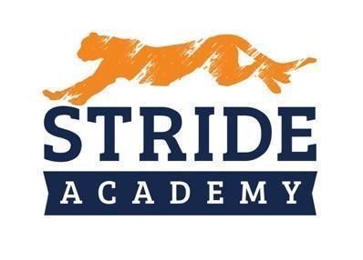

BOARD OF EDUCATION
STAFFING RECOMMENDATIONS

Administrator Making Recommendation: Angie Lichy

Department: Principal K-4 Date: 11/30/2022

Name of Candidate Recommended: Kym Craven

☐ Resume Included (Yes) ☐ Social Media Screen (Yes)

☐ References Checked (Yes) ☐ Valid/Appropriate Licensure Graduates 12.14.2022(Yes)

Position
- Position being filled: Special Education Teacher
- How did the vacancy occur? X☐ New Position ☐ Retirement. ☐ Resignation
- Who is being replaced? NEW
- Has the position or vacancy been changed or modified? ☐Yes X☐ No How?

Salary
Experience: First Year Teacher graduates with degree end of December 12/2022

Education: Special Education Degree

Proposed Salary: $43,219 PRORATED Hiring Bonus $2,000
OR
Proposed Hourly:

Extent of Employment (FTE): 1.0
OR
Number of Hours per Week:

Source of Funding:

General Fund: ☐ Special Education: X☐ Other: ☐ (Identify)

Selection Process

Interview Team: Angie LIchy and Nathan Schwieters
Number of candidates interviewed 1 out of 1 applications

  - Internal
  - External

Key issue(s) or qualities for decision: Prior Connection/ ASD experience and EBD

