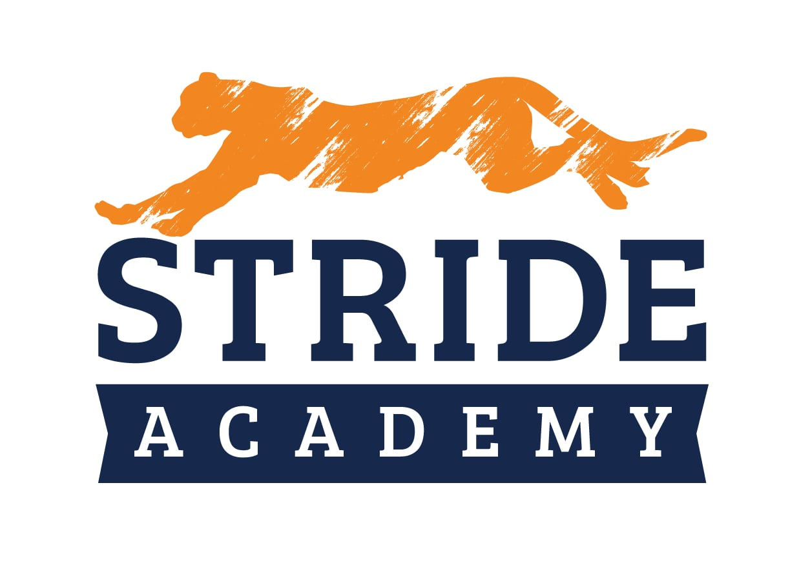
STRIDE ACADEMY VTO

ORGANIZATION NAME: STRIDE ACADEMY

VISION

CORE VALUES | - Academic Excellence (Achievement)  - Whole Child (Balance)  - School Community (Belonging)  - Lifelong Learning (Commitment)  - Fiscal Responsibility ( Prudence) | 3-YEAR PICTURE™
Future Date: 7/1/2025
700 Student Enrollment
Profit: $
Measurables:
What does it look like?

CORE FOCUS™ | Purpose/Cause/Passion: STRIDE Academy nurtures individuals while fostering leadership and empowering students to attain their highest potential in a family-centered environment.  Our Niche: Private School Experience in a Public School Setting
10-YEAR TARGET™ | A PK-12 Minnesota Charter School  1000 Students
MARKETING  STRATEGY | Target Market/“The List”:  Three Uniques™:  - Small Class Sizes  - Commitment to Equity and Social Justice  - Whole Child Education  Proven Process:  Guarantee:
THE VISION/TRACTION ORGANIZER™

STRIDE ACADEMY
TRACTION
1-YEAR PLAN | ROCKS | ISSUES LIST
Future Date:  Revenue: $  Profit: $  Measurables:  Goals for the Year:  1.  2.  3.  4.  5.  6.  7.  With your cursor in the last row, press Tab to add another row. | Future Date:  Revenue: $  Profit: $  Measurables:  Rocks for the Quarter: Who  1.  2.  3.  4.  5.  6.  7.  With your cursor in the last row, press Tab to add another row. | 1.  2.  3.  4.  5.  6.  7.  8.  9.  10.  With your cursor in the last row, press Tab to add another row.

