STRIDE Academy MS Facility Acquisition Project Update
5/20/2026
STRIDE Academy, through its affiliated building company, STRIDE Academy Building Company, continues to work toward acquiring its middle school campus at 3701 33rd St. St. Cloud, MN. The project also includes refinancing the adjacent land to the elementary school that was acquired in 2022 and provides funding for capital improvements at the middle school campus. Currently, the total project cost is estimated to be $22,652,131 with a projected closing date mid-July 2027. See sources and uses exhibit below.
- Brief Background of Project and Facility Strategy
- Upon the closure of Athlos Academy, in May 2025, STRIDE Academy entered into a lease agreement for the middle school campus. Currently the lease runs through June 2027.
- The Lease Agreement includes a $18,000,000 Purchase Option. The purchase option, currently must be exercised by June 1st, 2026, includes a $180,000 earnest money deposit at the time of executing the option, and establishes an outside closing date of September 1st.
- To better align with the closing schedule and to manage earnest money risk, STRIDE Academy has received verbal agreement with the seller for a 4th amendment to the lease extending the purchase option date to July 10th and the outside closing date to October 10th. Furthermore, we have received verbal agreement with the seller to reduce the purchase price by $600,000 to better address HVAC deficiencies that were identified in the middle school property inspection.
  - Recommended Board Action: Authorization for Eric Skanson to enter into a 4th amendment to the lease reducing the purchase price to $17,400,000 and extending the purchase option date to July 10th, 2026 or beyond.
- On March 30th, 2026, STRIDE Academy received a positive Review and Comment approval from the Minnesota Department of Education to acquire the site.
- STRIDE Academy’s Two Site Expansion Goals

- Immediate site control through a lease and parallel pursuit of long-term ownership immediately supported potentially displaced students, reduces competition risk, and establishes a feeder program of two sites in close 1 mile proximity to each other.
- The 3701 33rd St. South St. Cloud, MN campus supports growth to 1,002 K-8 students by the 2030-2031 school year.
- Aligned to STRIDE’s strategic plan, The 2nd site provides move in ready expansion space to support the growth to high school, when grade level expansion is approved.
- The financing ensures fixed lease costs, provides greater school control over facility management, and supports renovations now and in the future.

- Tax-Exempt Bond Financing Overview

- Multiple financing options were identified and assessed including bank financing, bank qualified bond financing, additional tax-exempt bond financing, and alternative sources (bond funds, CDFI’s, etc.). Ultimately, issuing additional tax-exempt bonds provides our best option, combining affordability, flexibility to work with our existing financing and a high likelihood of closing. With other financing options, a wrapped financing structure is more difficult and the subordinate loan would be very large, making it challenging, if not impossible, to source.
- Raymond James & Associates Inc., an experienced bond underwriter, has been engaged to manage the bond issuing process and will market and sell the bonds to investors.
- Raymond James is currently pursuing a 35-year, wrapped tax-exempt bond structure with 2026 interest only debt service through 2046 and Principal and Interest through 2061. See exhibit below.
- The project forecasts $1,571,850 additional annual debt service and an aggregate $2,659,850 per year debt service when combined with the existing 2016 debt service.
- Key Covenants and Bond Provisions: We are pursuing a reduction in the DCOH covenant from 60 days with short-term borrowing to 45 days without short-term borrowing, a reduction of DSCR from 1.2 to 1.10, and a combined capital reserve fund that can be used across all sites.
- We are working with Creative Planning and Choice Bank to reinstate the $250,000 Line of Credit
- To assess affordability, Creative Planning has worked with the STRIDE Academy team to provide 5 year budget projections that both meet programmatic needs, meet loan covenants, and maintain appropriate fund balance for long-term sustainable operations. See exhibit below

- Sources and Uses of Funds – 2026
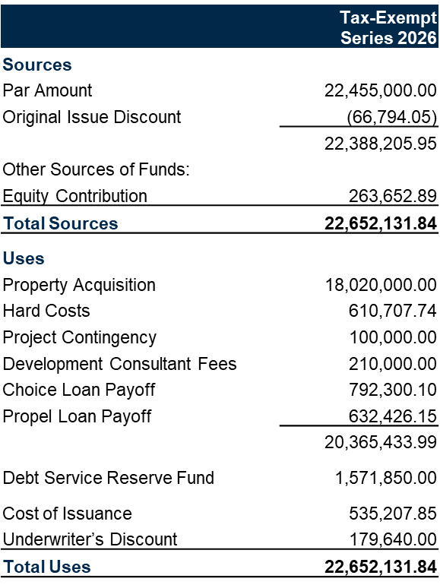

- Aggregate Debt Service – Series 2016 and 2026

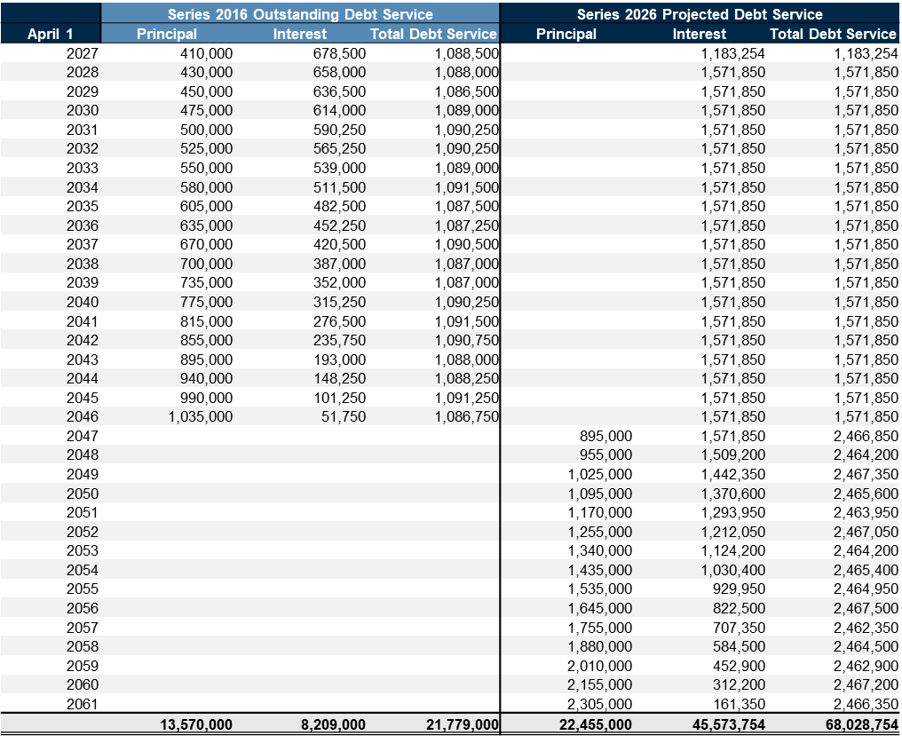

- Projected Financial Metrics
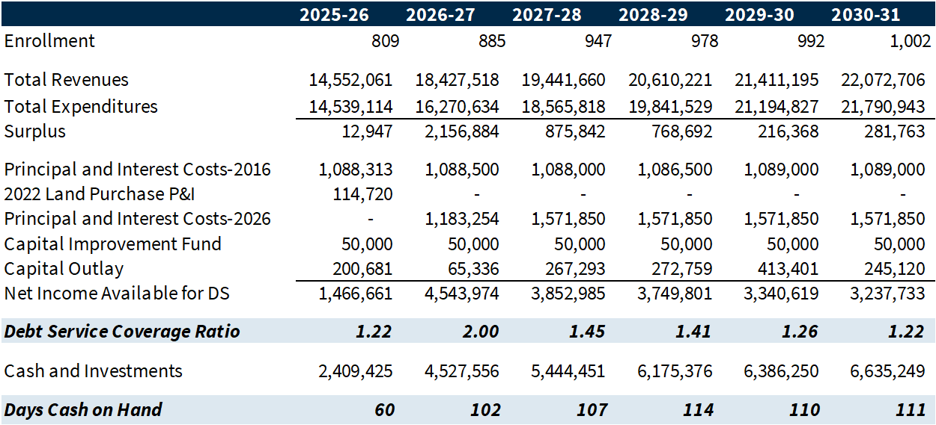
- Estimated Project Schedule

- June 1st: City of St. Cloud Public Hearing for Tax-Exempt Bond Issuance
- June 18th: Raymond James Prints Preliminary Offering Statement
- July 8th: Price Bonds
- July 10th: Exercise Purchase Option with Seller
- Week of July 20th: Close on Bonds.

