ABC Review and Comment Submission

July 2022

The following Review and Comment Submission was approved by the STRIDE Academy school board on July 21, 2022. This submission has been developed to seek a positive review from the Minnesota Department of Education so the STRIDE Academy Building Company can acquire adjacent land next to the school’s current site at 3241 Oakham Lane St. Cloud, Minnesota, to provide outdoor play space and available land for any possible future expansion.

July 22, 2022

Commissioner Heather Mueller
Minnesota Department of Education
1500 Highway 36 West
Roseville, MN 55113-4266

RE: Review and Comment Submittal for STRIDE Academy, a Minnesota Public Charter School

Dear Commissioner Mueller:

Pursuant to M.S. 123.71, the STRIDE Academy Board of Directors, the STRIDE Academy Building Company, and the Director of STRIDE Academy are pleased to submit this Review and Comment document for action by the Minnesota Department of Education.

STRIDE Academy is a K-8 charter school that currently serves 500 students in an educational campus at 3241 Oakham Lane St. Cloud, Minnesota. The student population consists of 80% students of color, 78% of which qualify for free and reduced lunches, and 55% of which are Multilingual Learners. STRIDE Academy is currently starting its eighteenth year of operation and is authorized by Pillsbury United Communities

In 2016 STRIDE Academy formed an affiliated building company and purchased and improved the school property at 3241 Oakham Lane St. Cloud, Minnesota. STRIDE Academy Building Company (the Sponsor) currently seeks to acquire two adjacent parcels, totaling 324,403 square feet. The additional land will provide needed outdoor play space and room for potential future expansion, if ever needed. STRIDE Academy Building Company will finance this project using bank financing from Choice Bank and Propel Nonprofits.

The total project cost is estimated at approximately $1,469,736 which will be financed using bank financing. Approximately $1,264,375 will be used to for property acquisition and due diligence, and the remainder will be used to pay for the transaction, development, legal, and financing costs. Ten Square is providing development management and consulting.

This review and comment submittal to MDE seeks to allow the STRIDE Academy Building Company to acquire the additional land for needed outdoor play space.

Since STRIDE Academy is a Minnesota public charter school, this project does not require voter approval through a bond referendum election. The STRIDE Academy Board of Directors approved this Review and Comment document at is July 21, 2022, school board meeting.

Thank you for the opportunity to present STRIDE Academy’s facility plan for your review and comment. Should you have any questions, please free to call or email me at your convenience.

Sincerely,

Eric Skanson
Executive Director
STRIDE Academy

eskanson@strideacademy.org
320-492-3462

STRIDE Academy Review and Comment Submission Information

A school board proposing projects requiring review and comment shall submit to the commissioner a proposal containing the following information:

- The geographic area and population to be served
STRIDE Academy is an open enrollment public charter school currently serving students in grades kindergarten through 8th grade. The school is currently located in St. Cloud and serves families that live in St. Cloud as well as surrounding communities of Sartell, Sauk Rapids, St. Joseph, Waite Park, Foley, Rice, Richmond, South Haven, and St. Augusta.

The map below shows where the school’s families currently reside.

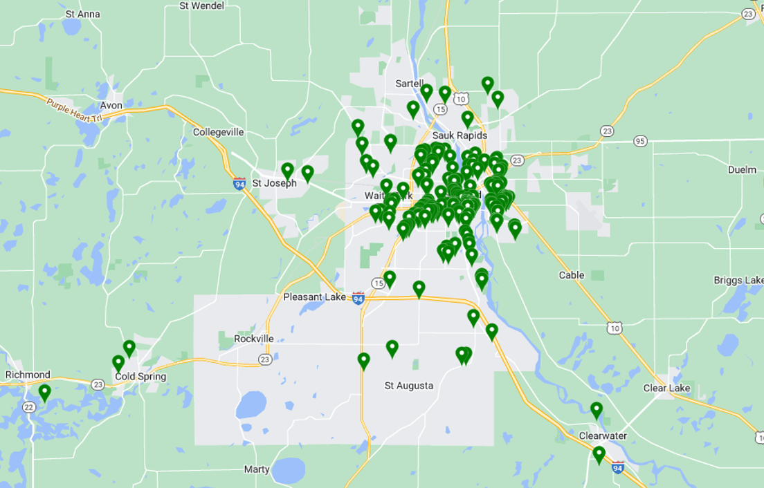

Student Enrollment
The following tables provide historical (as of October 1 of each school year) and projected enrollment information.

- Grade -specific preschool through grade 12 enrollment for the past five years

STRIDE Academy Historical Enrollment by Grade and Year,

FY 2018- FY 2022
School Year | K | 1 | 2 | 3 | 4 | 5 | 6 | 7 | 8 | Total
2017-18 | 37 | 52 | 57 | 45 | 46 | 42 | 28 | - | - | 307
2018-19 | 51 | 49 | 59 | 68 | 47 | 48 | 43 | - | - | 365
2019-20 | 56 | 59 | 65 | 62 | 68 | 47 | 47 | 45 | - | 449
2020-21 | 43 | 53 | 52 | 53 | 65 | 61 | 47 | 44 | 38 | 456
2021-22 | 57 | 58 | 56 | 66 | 63 | 71 | 64 | 46 | 44 | 525

- Grade-specific student enrollment projections for five years beyond the current year

STRIDE Academy Enrollment Count and Projections

FY 2023 -FY 2027

School Year | K | 1 | 2 | 3 | 4 | 5 | 6 | 7 | 8 | Total
2022-23 | 55 | 55 | 55 | 55 | 55 | 60 | 68 | 60 | 48 | 511
2023-24 | 55 | 55 | 55 | 55 | 55 | 60 | 60 | 68 | 60 | 523
2024-25 | 55 | 55 | 55 | 55 | 55 | 60 | 60 | 60 | 68 | 523
2025-26 | 55 | 55 | 55 | 55 | 55 | 60 | 60 | 60 | 68 | 523
2026-27 | 55 | 55 | 55 | 55 | 55 | 60 | 60 | 60 | 68 | 523

A list of existing facilities by year constructed
- By year constructed with subsequent building additions identified by age and square footage

STRIDE Academy is current a one building campus. The current building was originally built in 2010 providing 20,354 square feet. Three subsequent renovation phases have occurred in 2012 (6,984 additional sf), 2013 (5112 additional sf), and 2016 (39,350 additional sf). Current total square ft of the building is 71,800.

- Their uses
The building is used as a K-8 elementary school.

- An assessment of the extent to which alternate facilities are available within the school district boundaries
The district owns only one building. No alternate facilities exist within this district or are appropriate for Stride Academy play space needs.

- An in adjacent school districts
The school seeks additional outdoor play space. A play space that is not adjacent to the school would not be workable.

- A list of specific deficiencies of the facility

- Demonstrating the need for a new or renovated facility to be provided

STRIDE Academy seeks to acquire 324,403 square feet of additional land immediately north of the school’s current property. In the past, the school has been able to lease nearby play space for outdoor activities and physical education, however, that leased space is no longer available. We believe it is important for every child to have access to outdoor play space in order to promote health and wellness. Given the number of students we have in the school, and the loss of the formerly leased space, the additional land will ensure that the school and its students have appropriate access to outdoor play space and learning environments.

- The process used to determine the deficiencies, included completed facilities studies and facility committee findings/recommendations

In the past, as mentioned above, the school was able to lease nearby play space. When that available leased space was eliminated, the school board, administration, and academic community engaged with the nearby property owner to discuss acquisition of additional land and are now recommending the purchase when feasible.

- A list of identified deficiencies that will not be addressed by the proposed projects

Once this project is completed, we do not believe there will be any identified deficiencies at our current site.

- A list of specific benefits that the new or renovated facility and/or site will provide to students, teachers, and community users served by the facility

- The additional land will dramatically improve our students’ physical education experience and outdoor play area at the school. Formerly leased space was a temporary solution and the newly owned parcels will provide long-term outdoor play space accommodations for the STRIDE Academy community

- Our physical education teachers will benefit from the additional play space. They will have an appropriate outdoor teaching space for their subject. The new outdoor space will also be able to be used for other school gatherings and other special events.

- While not an immediate component of the current project, the additional land provides room for potential future expansion, if ever desired or needed.

- A description of the project including:

- Specifications of the site and outdoor space acreage

STRIDE Academy Building Company seeks to acquire two adjacent parcels, totaling 324,403 square feet, or 7.45 acres. The additional land will provide needed outdoor play space and room for potential future expansion, if ever desired or needed. The square footage and acreage of the two parcels that are being acquired are provided below

Parcel One: 106,603 sf, 2.45 acres
Parcel Two 217,800 sf, 5 acres

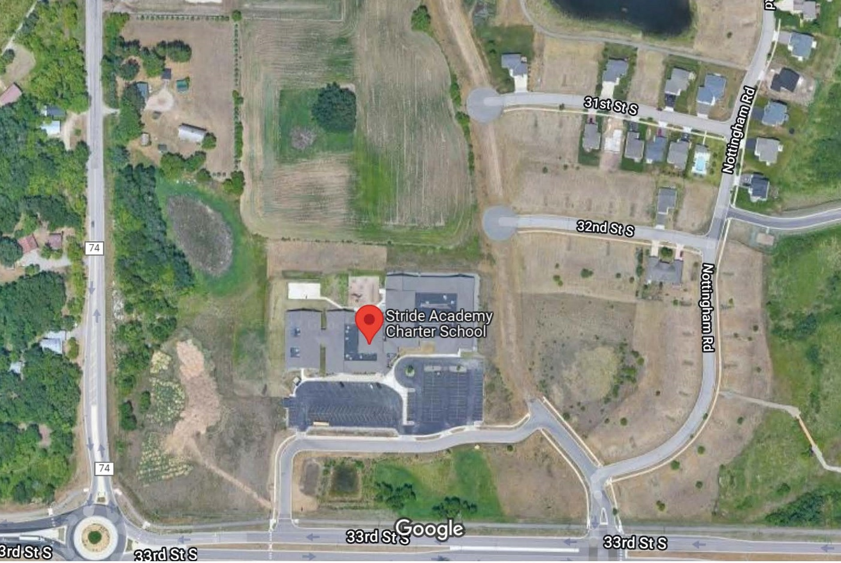

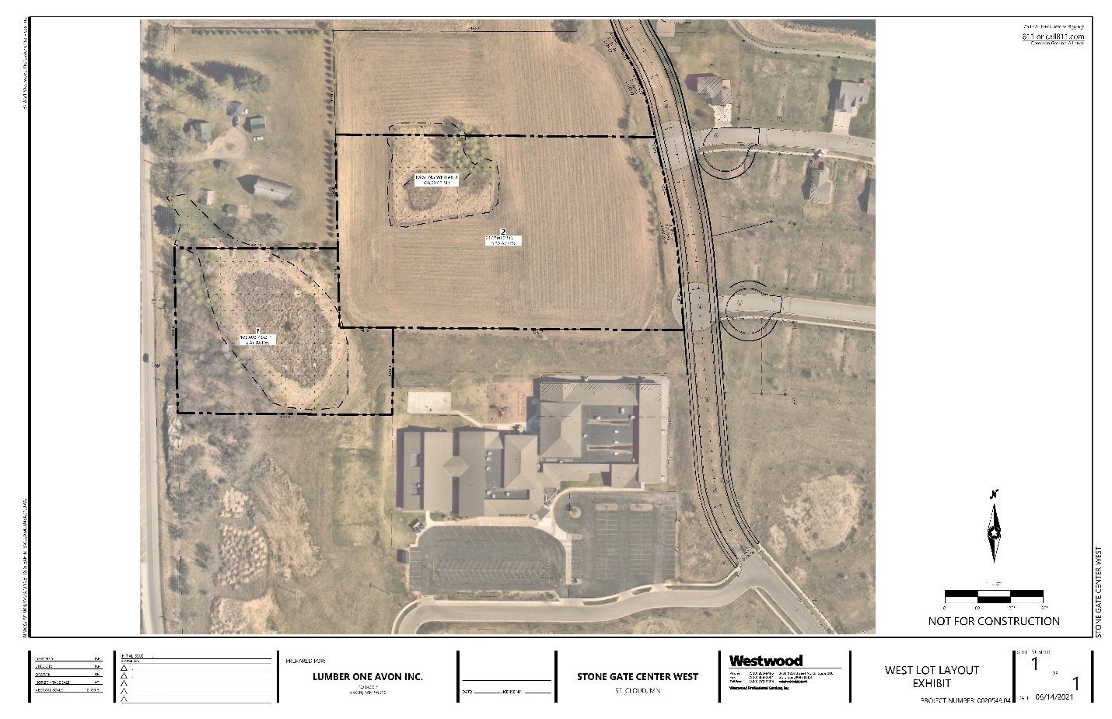

The current Stride Academy facility and parking area consists of 5.3 acres. The additional 7.45 acres of land will provide Stride Academy with 12.75 total acres of land.

- Square footage allocations for classrooms, laboratories and support spaces

The currently proposed project does not seek any renovations to the existing school space. However, the current facility consists of three masonry buildings, and associated parking. The facility has 34 classrooms, 11 special purpose education and laboratory rooms, a health office, two gymnasiums, kitchen, cafeteria, and associated administrative offices. Of the 71,800 square foot building, the average classroom size is 860 sf, gym #1 is 5,568 sf, gym #2 is 7,154 sf, science lab is 1,068 sf, intervention/EL classrooms are 613 sf, and the serving kitchen is 392 sf.

- Estimated expenditures for major portions of the project

Expenditures for the Project:
Property Acquisition | $ 1,264,376
Improvements - Hard Costs | $ -
Soft Costs (Including Commissions) | $ 115,060
Capitalized Interest | $ -
Debt Service Reserve | $ -
Project Contingency | $ 40,300
Development Consultant Fees | $ 50,000
Total Project Costs | $ 1,469,736

- Estimated changes in facilities operating costs
- Building related costs
STRIDE Academy anticipates minimal additional building related costs related to the acquisition of the additional land other than minor mowing and maintenance. Estimated additional exterior landscaping/maintenance costs are project to be $10,000 per year

- No additional programmatic staff will be necessary. STRIDE already offers the desired amount of PE classes, we just need a better outdoor space, since past leased outdoor space is no longer available.

- Dates the project will begin and be completed

The acquisition of the additional land should be completed by October 1, 2022. After minor mowing and maintenance access to the additional outdoor play space is anticipated in late October 2022.

- A specification of the source of project financing including

- Applicable statutory citations

- The schedules for the date for a bond issue or school board action

- A schedule of payment, including debt service equalization aid

- The effect of the bond issues on local property taxes by property class and valuation

By law, charter schools cannot own their own facilities, nor can they levy taxes or secure bond financing to buy property and build schools. Charter schools may work with affiliated building companies (“ABCs”), or other nonprofit entities that own and bond for facilities on the behalf of charter schools.

STRIDE Academy has an established an Affiliated Building Company called STRIDE Academy Building Company, which owns the facility at 3241 Oakham Lane St. Cloud, Minnesota. STRIDE Academy’s use of the building is detailed by a long-term lease agreement between STRIDE Academy ABC and STRIDE Academy. The current lease agreement which includes debt service on existing bonds will be amended to include the additional debt service cost for the land acquisition, which is estimated at an additional $117,472 per year.

STRIDE Academy Building Company plans to finance the acquisition of the additional land with a combination of Senior Bank Financing from Choice Bank ds ($970,000) and Subordinate Debt Financing from Propel Nonprofits ($499,736). The financing will be amortized over 25 years with a 5 year fixed rate. There is no financial risk to the City of St. Cloud or the State of Minnesota. STRIDE Academy Building Company plans close by October 1, 2021.

The sources and uses of funds are provided below with the proceeds of financing to be used for the acquisition of the adjacent land for use by STRIDE Academy.

STRIDE Academy Building Company Bank Financing

Sources of Financing
Senior Financing (Choice Bank) | $ 970,000
Subordinated Debt (Propel Nonprofits) | $ 499,736
Other Financing | $ -
Subordinated Debt (CDFI - TBD) | $ -
Equity | $ -
Total Project Financing | $ 1,469,736

Uses of Financing
Property Acquisition | $ 1,264,376
Improvements - Hard Costs | $ -
Soft Costs (Including Commissions) | $ 115,060
Capitalized Interest | $ -
Debt Service Reserve | $ -
Project Contingency | $ 40,300
Development Consultant Fees | $ 50,000
Total Project Costs | $ 1,469,736

This project will have no impact on local property taxes, The property is currently tax exempt.

A 5-year STRIDE Academy budget projection is included as Attachment 2. The schedule of debt service payments is included in Attachment 3.

- Documentation obligating the school district and contractors to comply with the following items:

- Minnesota Statutes, section 471.345 governing municipal contracts
- Sustainable design
- School facility commissioning under Minnesota Statutes, section 123B.72, certifying the plans and designs for heating, ventilating, air conditioning and air filtration for an extensively renovated or new facility meet or exceed current code standards, including American Society of Heating, Refrigerating and Air-Conditioning Engineers (ASHRAE) air filtration Standard 52.1
- American National Standards Institute (ANSI) acoustical performance criteria, design requirements and guidelines for schools on maximum background noise levels and reverberation times
- State fire code
- Minnesota Statutes, chapter 326B governing building codes
- Consultation with affected government units about the impact of the project on utilities, roads, sewers, sidewalks, retention ponds, school bus and automobile traffic, access to mass transit and safe access for pedestrians and cyclists

Attachment 1 provides signed documentation obligating STRIDE Academy and its contractors to comply with Minnesota Statute 471.345, Minnesota Statute 123B.72 and Minnesota Statute chapter 326B throughout any construction project and maintenance of documentation showing compliance with these items upon and subsequent to project completion.

Attachment 1
Review and Comment
Section #6 Documentation
(as amended by the 2014 Legislature)

The current facility is functioning and occupied by STRIDE Academy. For any contracted activities on the purchased land, STRIDE Academy ABC will cause its contractors to comply with items (i) to (vii) in planning and executing the development:

(i) The school district will be in compliance with Minnesota Statute 471.345 governing municipal contracts issued for this Facility;

(ii) The school district and the architects will include elements of sustainable design for this Facility;

(iii) If the Facility installs or modifies facility mechanical systems, the school district,
architect/engineers and contractors will be in compliance with school facility commissioning under Minnesota Statute 123B.72 certifying the plans and designs for the heating, ventilating, air conditioning, and air filtration for an extensively renovated or new facility meet or exceed current code standards, including the ASHRAE air filtration standard 52.1;

(iv) If the Facility creates or modifies interior spaces, the district, architects/engineers and relevant contractors have considered the American National Standards Institute Acoustical Performance Criteria, Design Requirements and Guidelines for Schools on maximum background noise level and reverberation times;

(v) The Facility will be in compliance with Minnesota State Fire Code;

(vi) The Facility will be in compliance with Minnesota Statute chapter 326B governing
building codes; and

(vii) The school district and the architects/engineers have been in consultation with
affected government units about the impact of the Facility on utilities, roads, sewers, sidewalks, retention ponds, school bus and automobile traffic, access to mass transit, and safe access for pedestrians and cyclists. The school district and architect/engineers will maintain documentation showing compliance with these items upon and subsequent to Facility completion.

Executive Director Signature: ______________________________ Date ____________
Board Chair Signature: _______________________________ ____ Date ____________

Attachment #2
Review and Comment
Long Range Budget Projection

See attached

Attachment #3
Schedule of Debt Service Payments

See attached

