ABC Review and Comment Submission

May 2023
Updated – January 2024

The following Review and Comment Submission was approved by the STRIDE Academy school board on May 18, 2023. This submission has been developed to seek a positive review from the Minnesota Department of Education so the STRIDE Academy Building Company can expand its facility and outdoor play space at its school site located at 3241 Oakham Lane St. Cloud, Minnesota, to meet growing demand and the needs of current and future learners at STRIDE Academy.

The following updated Review and Comment Submission was approved by the STRIDE Academy school board on January 18, 2024.

The STRIDE Academy Board of Directors, the STRIDE Academy Building Company, and the Director of STRIDE Academy are submitting this REVISED Review and Comment document to the Minnesota Department of Education. There are no material changes to the cost or programmatic benefits of the project. However, the architectural design and delivery date for a portion of the project have changed. To ensure aligned approval and communication, STRIDE Academy is adopting this revised Review and Comment and submitting to the MDE with changes noted in blue.

May 18, 2022
Updated January 18, 2024

Commissioner Heather Mueller
Minnesota Department of Education
1500 Highway 36 West
Roseville, MN 55113-4266

RE: Review and Comment Submittal for STRIDE Academy, a Minnesota Public Charter School

Dear Commissioner Mueller:

Pursuant to M.S. 123.71, the STRIDE Academy Board of Directors, the STRIDE Academy Building Company, and the Director of STRIDE Academy are pleased to submit this Review and Comment document for action by the Minnesota Department of Education.

STRIDE Academy is a K-8 public charter school that currently serves 541 students in an educational campus at 3241 Oakham Lane St. Cloud, Minnesota. The student population consists of 85% students of color, 85% of which qualify for free and reduced lunches, and 49% of which are Multilingual Learners. STRIDE Academy is currently completing its eighteenth year of operation and is authorized by Pillsbury United Communities

In 2016, STRIDE Academy formed an affiliated building company and purchased and improved the school property at 3241 Oakham Lane St. Cloud, Minnesota. In 2022, STRIDE Academy Building Company acquired two adjacent parcels to provide needed outdoor play space and room for potential future expansion.

STRIDE Academy Building Company currently seeks to finance a 14,686 13,560 square foot building expansion, renovations of the existing building, and site improvements to meet growing demand and enrollment growth to 824 K-8 students in FY30. The project will provide 8 additional classrooms, a dedicated cafeteria/multipurpose space, a new soccer field/play space, playground relocation, a new gymnasium and additional office/student support spaces in the existing building to better support English language learners, special education students, and administrative needs.

The total project cost is estimated at $8,288,401 which will be financed using additional tax-exempt bonds. Approximately $5,231,434 will be used to complete construction and site improvements, $1,496,736 will be used to refinance the 2022 land acquisition bank loan, $494,244 will be used for debt service reserve, and the remainder will be used to pay for the transaction, including design costs, legal fees, and financing costs. TenSquare is providing development management and consulting.

The total REVISED project cost is estimated at $8,419,212.50 which will be financed using additional tax-exempt bonds. Approximately $5,082,002 will be used to complete construction and site improvements, $1,525,738 will be used for due diligence and to refinance the 2022 land acquisition bank loan, $567,350 will be used for debt service reserve, and the remainder will be used to pay for the transaction, including design costs, legal fees, and financing costs. TenSquare is providing development management and consulting.

STRIDE Academy is in good standing with its trustee and investors. The financial health of the school and the size and scope of the new project meet the additional-indebtedness requirements within the exiting bond covenants.

This review and comment submittal to MDE seeks to allow the STRIDE Academy Building Company to secure additional tax-exempt bonds to finance the expansion, site improvements, and existing building renovations at 3241 Oakham Lane in St. Cloud.

Since STRIDE Academy is a Minnesota public charter school, this project does not require voter approval through a bond referendum election. The STRIDE Academy Board of Directors approved this Review and Comment document to be submitted to the Commissioner of Education at its May 18, 2023 school board meeting.

Thank you for the opportunity to present STRIDE Academy’s facility plan for your review and comment. Should you have any questions, please free to call or email me at your convenience.

Sincerely,

Eric Skanson
Executive Director
STRIDE Academy

eskanson@strideacademy.org
320-492-3462
STRIDE Academy Review and Comment Submission Information

A school board proposing projects requiring review and comment shall submit to the commissioner a proposal containing the following information:

- The geographic area and population to be served
STRIDE Academy is an open enrollment public charter school currently serving students in grades kindergarten through 8th grade. The school is currently located in St. Cloud and serves families that live in St. Cloud as well as surrounding communities of Sartell, Sauk Rapids, St. Joseph, Waite Park, Foley, Rice, Richmond, South Haven, and St. Augusta.

The map below shows where the school’s families currently reside.

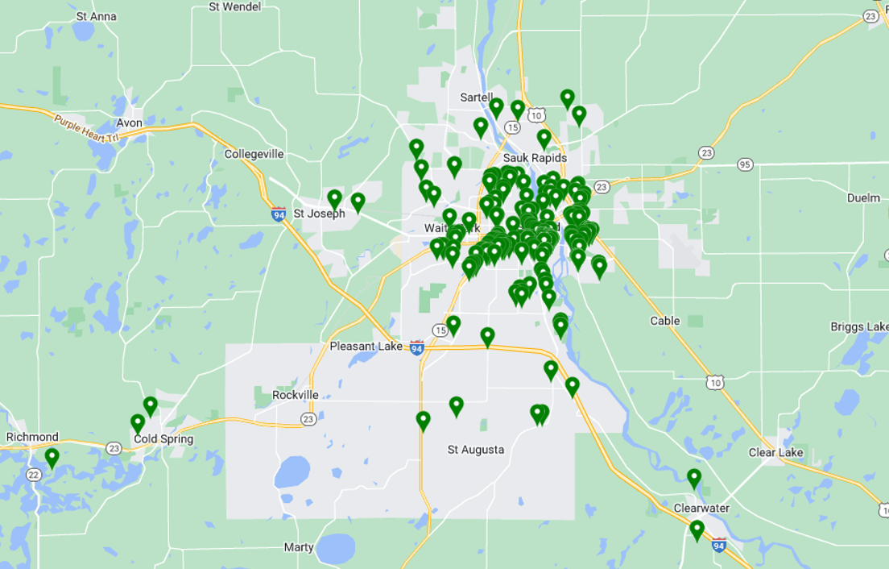

Student Enrollment
The following tables provide historical (as of October 1 of each school year) and projected enrollment information.

- Grade -specific preschool through grade 12 enrollment for the past five years

STRIDE Academy Historical Enrollment by Grade and Year,

FY 2019- FY 2023
School Year | K | 1 | 2 | 3 | 4 | 5 | 6 | 7 | 8 | Total
2018-19 | 51 | 49 | 59 | 68 | 47 | 48 | 43 | - | - | 365
2019-20 | 56 | 59 | 65 | 62 | 68 | 47 | 47 | 45 | - | 449
2020-21 | 43 | 53 | 52 | 53 | 65 | 61 | 47 | 44 | 38 | 456
2021-22 | 57 | 58 | 56 | 66 | 63 | 71 | 64 | 46 | 44 | 525
2022-23 | 45 | 57 | 65 | 64 | 71 | 70 | 72 | 55 | 45 | 544

- Grade-specific student enrollment projections for five years beyond the current year

STRIDE Academy Enrollment Count and Projections

FY 2023 - FY 2028

School Year | K | 1 | 2 | 3 | 4 | 5 | 6 | 7 | 8 | Total
2023-24 | 80 | 80 | 88 | 72 | 72 | 72 | 72 | 72 | 72 | 680
2024-25 | 80 | 80 | 88 | 96 | 72 | 72 | 72 | 72 | 72 | 704
2025-26 | 80 | 80 | 88 | 96 | 96 | 72 | 72 | 72 | 72 | 728
2026-27 | 80 | 80 | 88 | 96 | 96 | 96 | 72 | 72 | 72 | 752
2027-28 | 80 | 80 | 88 | 96 | 96 | 72 | 96 | 72 | 72 | 776

REVISED - STRIDE Academy Enrollment Count and Projections

FY 2023 - FY 2028

School Year | K | 1 | 2 | 3 | 4 | 5 | 6 | 7 | 8 | Total
2023-24 | 68 | 68 | 68 | 63 | 63 | 68 | 70 | 70 | 57 | 595
2024-25 | 72 | 72 | 72 | 75 | 70 | 70 | 72 | 72 | 72 | 647
2025-26 | 76 | 78 | 78 | 80 | 82 | 72 | 72 | 72 | 72 | 682
2026-27 | 80 | 80 | 83 | 83 | 86 | 87 | 72 | 72 | 72 | 715
2027-28 | 80 | 80 | 85 | 88 | 88 | 90 | 92 | 72 | 72 | 747

A list of existing facilities by year constructed
- By year constructed with subsequent building additions identified by age and square footage

STRIDE Academy is currently a single-story campus. The current building was originally built in 2010 providing 20,354 square feet. Three subsequent renovation phases have occurred in 2012 (6,984 additional sf), 2013 (5112 additional sf), and 2016 (39,757 additional sf). Current total square ft of the building is 72,207.

- Their uses

The building is used as a K-8 elementary school.

- An assessment of the extent to which alternate facilities are available within the school district boundaries

The district owns only one building. No alternate facilities are appropriate for Stride Academy’s goal of developing a contiguous building addition and a play space accessible to students.

- An in adjacent school districts
The school seeks to add a classroom, cafeteria, and play space addition to its current facility. An expansion in another district would not be workable.

- A list of specific deficiencies of the facility

- Demonstrating the need for a new or renovated facility to be provided

Since the acquisition of the building in 2016, STRIDE Academy has seen consistent growth in family demand and student retention, reaching full K-8th grade programming in FY21. Since 2021, STRIDE has added an additional 100 students, while serving the same grade levels.

Accommodating this growth has meant that specialist teachers no longer have dedicated classrooms, office/ELL/SPED/other spaces have been repurposed for homeroom classrooms, and grade level sections have been expanded beyond the preferred programmatic targets.

Furthermore, lunch operations to serve the larger student population in the exiting gymnasiums are extremely tight, while also providing sufficient space and scheduled programming time for physical education.

Given growing enrollment demand, STRIDE Academy has developed a growth plan to serve 4 sections per grade (47 planned classrooms) as compared to the current 3 sections per grade (39 classrooms). Given the existing square footage space deficiencies that exist for current school operations, supporting further growth will require additional facility space.

In addition, the STRIDE Academy facility is a single-story wood-framed building that does not allow for multi-story space efficiency or structural capacity to vertically expand. Additional classroom spaces, therefore, must be developed as full building additions.

Lastly, the existing site is deficient in providing sufficient green spaces for student play, extracurricular programming, and physical education. With the acquisition of additional land in 2022, STRIDE can now address this deficiency by developing a soccer/play field, additional hard-surface play space, and additional parking for events and extracurricular programming. STRIDE believes it is important for every child to have access to outdoor play space in order to promote health and wellness. Given the number of current STRIDE students, planned enrollment growth, the loss of the formerly leased field space, and the newly available land, the site improvements to this spaces will ensure appropriate access to outdoor play space and learning environments.

- The process used to determine the deficiencies, included completed facilities studies and facility committee findings/recommendations

In early 2022, STRIDE Academy was notified that it would lose access to previously leased field space. The school board, administration, and academic community engaged with the nearby property owner and successfully acquired additional land in November 2022. Simultaneously, the school board and administration engaged in a strategic planning process to not just address play space improvements, but to also evaluate enrollment growth and expansion. STRIDE engaged DSGW Architecture to complete a space utilization assessment, Braun Intertec to complete a Property Condition Assessment, and TenSquare as development manager to assess the feasibility of the project. Working with school administration and board on enrollment projections, concept plans were developed to maximize space efficiency in the current building and to assess the scope needs of a building addition. Ultimately, it was determined that STRIDE Academy could meet programmatic needs for the 2023-2024 school year with minor improvements to the existing building. However, in order to support enrollment growth in 2024-25 and beyond, STRIDE would need to pursue additional indebtedness to complete a building expansion and necessary site work.

- A list of identified deficiencies that will not be addressed by the proposed projects

Once this project is completed, we do not believe there will be any identified deficiencies at our current site.

- A list of specific benefits that the new or renovated facility and/or site will provide to students, teachers, and community users served by the facility

- Additional 8 classrooms will provide appropriate grade level section classroom size and will allow STRIDE Academy to expand to 4 sections per grade as students matriculate to an upper grade each year.
- Additional classrooms and renovations to existing space will allow specialist teachers to have dedicated subject matter classrooms
- Additional classrooms will increase and return use of dedicated student support space and office/administrative space
- The new cafeteria/multipurpose space will provide a dedicated lunch area that does not conflict with the physical education activities in the gymnasium
- A new soccer/green space will dramatically improve our students’ physical education experience and outdoor play area at the school.

- Our physical education teachers will benefit from the additional play space. They will have an appropriate outdoor teaching space for their subject.

- The new parking and hard surface play space will support arrival/drop off, provide hard-surface play area during the school day, and will provide additional parking for other school gatherings and special events.

- Renovations to existing building will improve student access to small group, ELL, SPED, and support spaces and improve middle school administrative staff spaces.

- The new addition will be designed to serve as a safe storm shelter for STRIDE Academy students and staff, in accordance with latest code and recommendations.

- While portions of existing gyms will be redesigned for classroom and cafeteria space, the newly constructed gymnasium will provide enhanced physical education space, event space, a regulation court for middle school sports, and better proximity to outdoor field space.

- A description of the project including:

- Specifications of the site and outdoor space acreage

The new classroom and cafeteria addition will be located on the north portion of the current building, where the current playground is located. The newly completed building, including the 14,686 sf addition, will total 86,893 square feet on the 5.3 acre parcel.

The new playground location, new soccer/play field, and new parking/hard-surface play area will be developed on the 217,800 sf, 5 acre parcel immediately north of the school that was acquired in 2022. The 106,603 sf, 2.45 acre parcel that was acquired in 2022 will not undergo any development at this time.

The newly completed building, including the 13,560 sf addition, will total 85,767 square feet. The new addition will include a new gymnasium, health classroom, band classroom, restrooms, and entry space. Improved outdoor space will include a new soccer/play field and a new parking/hard-surface play area which will be developed on the 217,800 sf, 5 acre parcel immediately north of the school that was acquired in 2022. The 106,603 sf, 2.45 acre parcel that was acquired in 2022 will not undergo any development at this time.

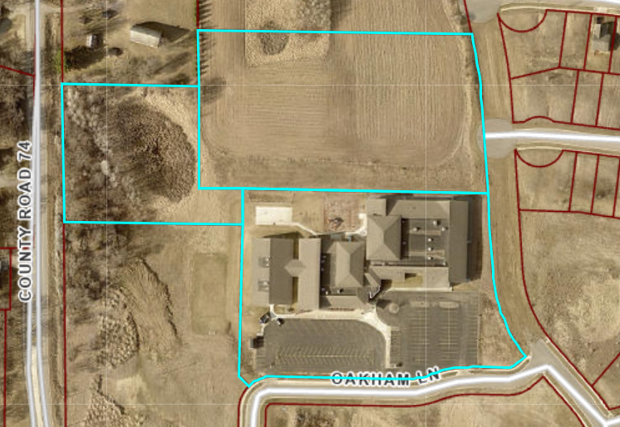

In total, Stride Academy Building Company owns 12.75 total acres of land.

- Square footage allocations for classrooms, laboratories and support spaces

The approximately 14,686 total square foot addition will provide a 2,518 sf cafeteria space, a 1,291 sf catering kitchen, a 743 sf 4th grade classroom, 2 836 sf 6th grade classrooms, a 614 sf middle school health classroom, a 964 sf middle school art classroom, an 886 elementary art classroom, a 1,065 sf English Language Arts classroom, a 1,116 middle school media center, two 283 sf toilets, and a 1,442 sf corridor/storm shelter.

Renovations to 3,170 sf of the existing building, while smaller, will improve and increase ELL, SPED, and administrative space.

In total the existing and new construction will consist of four slab on grade wood-framed buildings and associated parking. The facility will have 47 classrooms with dedicated classrooms for art, music, and science. The building will also include 10 small group special purpose, a health office, two gymnasiums, kitchen, cafeteria, and associated administrative offices. Of the 86,893 square foot building, the average classroom size is 860 sf, gym #1 is 5,568 sf, gym #2 is 7,154 sf, science lab is 800 sf, and intervention/EL classrooms average 180 sf.

Facility schematics, space configurations, and square footage allocations are provided in Attachment 2.
The approximately 13,560 total square foot addition will provide a 6,860 sf gymnasium, 250 sf gym storage space, 815 sf health classroom, 1,201 sf band classroom, restrooms, 1,715 sf corridor, and a reception area. The new construction will consist of precast concrete and EPDM roof that meets storm shelter requirements as well as wood-framed building structure with vinyl siding for non-storm shelter areas.

Renovations to 11,125 sf of the existing building will provide 1,012 sf Special Education space, 2 881 sf 8th grade classrooms, 808 sf middle school office, 2,436 middle school fitness space, 3629 sf dedicated cafeteria, middle school technology classroom, 764 sf 4th grade classroom, and a 980 sf elementary art classroom. STRIDE Academy is also seeking grant funds to renovate 284 sf for a gender-neutral restroom.

In total the existing and new construction will consist of three slab on grade wood-framed buildings, a slab on grade pre-cast building, and expanded parking and drive lanes. The facility will have 47 classrooms with dedicated classrooms for art, music, and science. The building will also include 10 small group special purpose, a health office, two gymnasiums, kitchen, cafeteria, and associated administrative offices. Of the 85,767 square foot building, the average classroom size is 860 sf, gym #1 is 2,436 sf, gym #2 is 6,860 sf, science lab is 800 sf, and intervention/EL classrooms average 180 sf.

Revised facility schematics, space configurations, and square footage allocations are provided in Attachment 2.

- Estimated expenditures for major portions of the project

Uses of Financing
Property Acquisition and Due Diligence | $ 1,496,736
Improvements - Hard Costs | $ 5,231,434
Soft Costs (Including Commissions) | $ 758,987
Capitalized Interest | $ -
Debt Service Reserve | $ 494,244
Project Contingency | $ 57,000
Development Consultant Fees | $ 250,000
Total Project Costs | $ 8,288,401

Uses of Financing
Property Acquisition and Due Diligence | $ 1,525,738
Improvements - Hard Costs | $ 5,082,002
Soft Costs (Including Commissions) | $ 924,780
Debt Service Reserve | $ 567,350
Project Contingency | $ 69,343
Development Consultant Fees | $ 250,000
Total Project Costs | $ 8,419,212

- Estimated changes in facilities operating costs

We estimate the additional 13,863 square feet will cost $6 per square feet in additional operating costs for an increase in operational costs of $83,178.

We estimate the additional 13,560 square feet will cost $6 per square feet in additional operating costs for an increase in operational costs of $81,360.

- Dates the project will begin and be completed

The planned closing date for the transaction is September 1, 2023 and the planned occupancy date is July 1, 2024.

The planned closing date for the transaction is February 13, 2024. The planned occupancy of the interior renovation is September 1, 2024. The planned occupancy of the new gym addition is December 1, 2024.

- A specification of the source of project financing including

- Applicable statutory citations

- The schedules for the date for a bond issue or school board action

- A schedule of payment, including debt service equalization aid

- The effect of the bond issues on local property taxes by property class and valuation

By law charter schools cannot own their own facilities, nor can they levy taxes or secure bond financing to buy property and build schools. Charter schools may work with affiliated nonprofit building corporations (“ABCs”) or other nonprofit entities that own and incur debt obligations for facilities on the behalf of charter schools. Thus, it is the ABC, or the third party and not the school who is obligated to pay the debt on the property and facility. STRIDE Academy Building Company has been formed solely to own and lease the properties for STRIDE Academy’s use. The two parties will enter into an amendment of the existing long-term lease agreement to be signed prior to closing of the additional bond financing.

STRIDE Academy Building Company plans to issue Tax Exempt Bonds ($8,419,212) using the City of St. Cloud as the bond issuer. The bonds will be issued and sold with the cooperation Robert W. Baird & Co., an experienced bond underwriter, that will manage the bond issuing process and will market and sell the bonds to investors. There is no financial risk to the City of St. Cloud or the State of Minnesota. STRIDE Academy Building Company plans to issue the Tax Exempt Bonds by February 13, 2024. The sources and uses of funds are detailed below with the proceeds of financing to be used for the expansion and further development of the STRIDE Academy Building Company properties for continued use as the permanent home for STRIDE Academy.

STRIDE Academy Building Company Project Sources and Uses with Tax Exempt Bond Financing

Sources of Financing
Senior Financing (Additional Tax-Exempt Bonds) | $ 7,565,309
Subordinated Debt (NA) | $ -
Long-Term Financing (taxable bonds) | $ -
Debt Service Reserve | $ 494,244
Equity (50% ABC RR & Choice Acct | $ 228,848
Total Project Financing | $ 8,288,401

Uses of Financing
Property Acquisition and Due Diligence | $ 1,496,736
Improvements - Hard Costs | $ 5,231,434
Soft Costs (Including Commissions) | $ 758,987
Capitalized Interest | $ -
Debt Service Reserve | $ 494,244
Project Contingency | $ 57,000
Development Consultant Fees | $ 250,000
Total Project Costs | $ 8,288,401

Sources of Financing
Senior Financing (Additional Tax-Exempt Bonds) | $ 7,537,650
Debt Service Reserve | $ 567,350
Equity (ABC Cap. Reserve & Choice Acct) | $ 314,213
Total Project Financing | $ 8,419,212

Uses of Financing
Property Acquisition and Due Diligence | $ 1,525,738
Improvements - Hard Costs | $ 5,082,002
Soft Costs (Including Commissions) | $ 924,780
Debt Service Reserve | $ 567,350
Project Contingency | $ 69,343
Development Consultant Fees | $ 250,000
Total Project Costs | $ 8,419,212

This project will have no impact on local property taxes, The property is currently tax exempt.

A 5-year STRIDE Academy budget projection is included as Attachment 3. The bonds are structured as 35-year fixed rate bonds. The schedule of debt service payments is included in Attachment 4.

A 5-year STRIDE Academy budget projection is included as Attachment 3. The bonds are structured as 30-year fixed rate bonds. The schedule of debt service payments is included in Attachment 4.

- Documentation obligating the school district and contractors to comply with the following items:

- Minnesota Statutes, section 471.345 governing municipal contracts
- Sustainable design
- School facility commissioning under Minnesota Statutes, section 123B.72, certifying the plans and designs for heating, ventilating, air conditioning and air filtration for an extensively renovated or new facility meet or exceed current code standards, including American Society of Heating, Refrigerating and Air-Conditioning Engineers (ASHRAE) air filtration Standard 52.1
- American National Standards Institute (ANSI) acoustical performance criteria, design requirements and guidelines for schools on maximum background noise levels and reverberation times
- State fire code
- Minnesota Statutes, chapter 326B governing building codes
- Consultation with affected government units about the impact of the project on utilities, roads, sewers, sidewalks, retention ponds, school bus and automobile traffic, access to mass transit and safe access for pedestrians and cyclists

Attachment 1 provides signed documentation obligating STRIDE Academy and its contractors to comply with Minnesota Statute 471.345, Minnesota Statute 123B.72 and Minnesota Statute chapter 326B throughout any construction project and maintenance of documentation showing compliance with these items upon and subsequent to project completion.

Attachment 1
Review and Comment
Section #6 Documentation
(as amended by the 2014 Legislature)

The current facility is functioning and occupied by STRIDE Academy. For any contracted activities on the purchased land, STRIDE Academy ABC will cause its contractors to comply with items (i) to (vii) in planning and executing the development:

(i) The school district will be in compliance with Minnesota Statute 471.345 governing municipal contracts issued for this Facility;

(ii) The school district and the architects will include elements of sustainable design for this Facility;

(iii) If the Facility installs or modifies facility mechanical systems, the school district,
architect/engineers and contractors will be in compliance with school facility commissioning under Minnesota Statute 123B.72 certifying the plans and designs for the heating, ventilating, air conditioning, and air filtration for an extensively renovated or new facility meet or exceed current code standards, including the ASHRAE air filtration standard 52.1;

(iv) If the Facility creates or modifies interior spaces, the district, architects/engineers and relevant contractors have considered the American National Standards Institute Acoustical Performance Criteria, Design Requirements and Guidelines for Schools on maximum background noise level and reverberation times;

(v) The Facility will be in compliance with Minnesota State Fire Code;

(vi) The Facility will be in compliance with Minnesota Statute chapter 326B governing
building codes; and

(vii) The school district and the architects/engineers have been in consultation with
affected government units about the impact of the Facility on utilities, roads, sewers, sidewalks, retention ponds, school bus and automobile traffic, access to mass transit, and safe access for pedestrians and cyclists. The school district and architect/engineers will maintain documentation showing compliance with these items upon and subsequent to Facility completion.

Executive Director Signature: ______________________________ Date ____________
Board Chair Signature: _______________________________ ____ Date ____________

Attachment #2
Review and Comment
Facility schematics, space configurations, and square footage allocations

Attachment #3
Review and Comment
Long Range Budget Projection

See attached

Attachment #4
Schedule of Debt Service Payments

See attached

