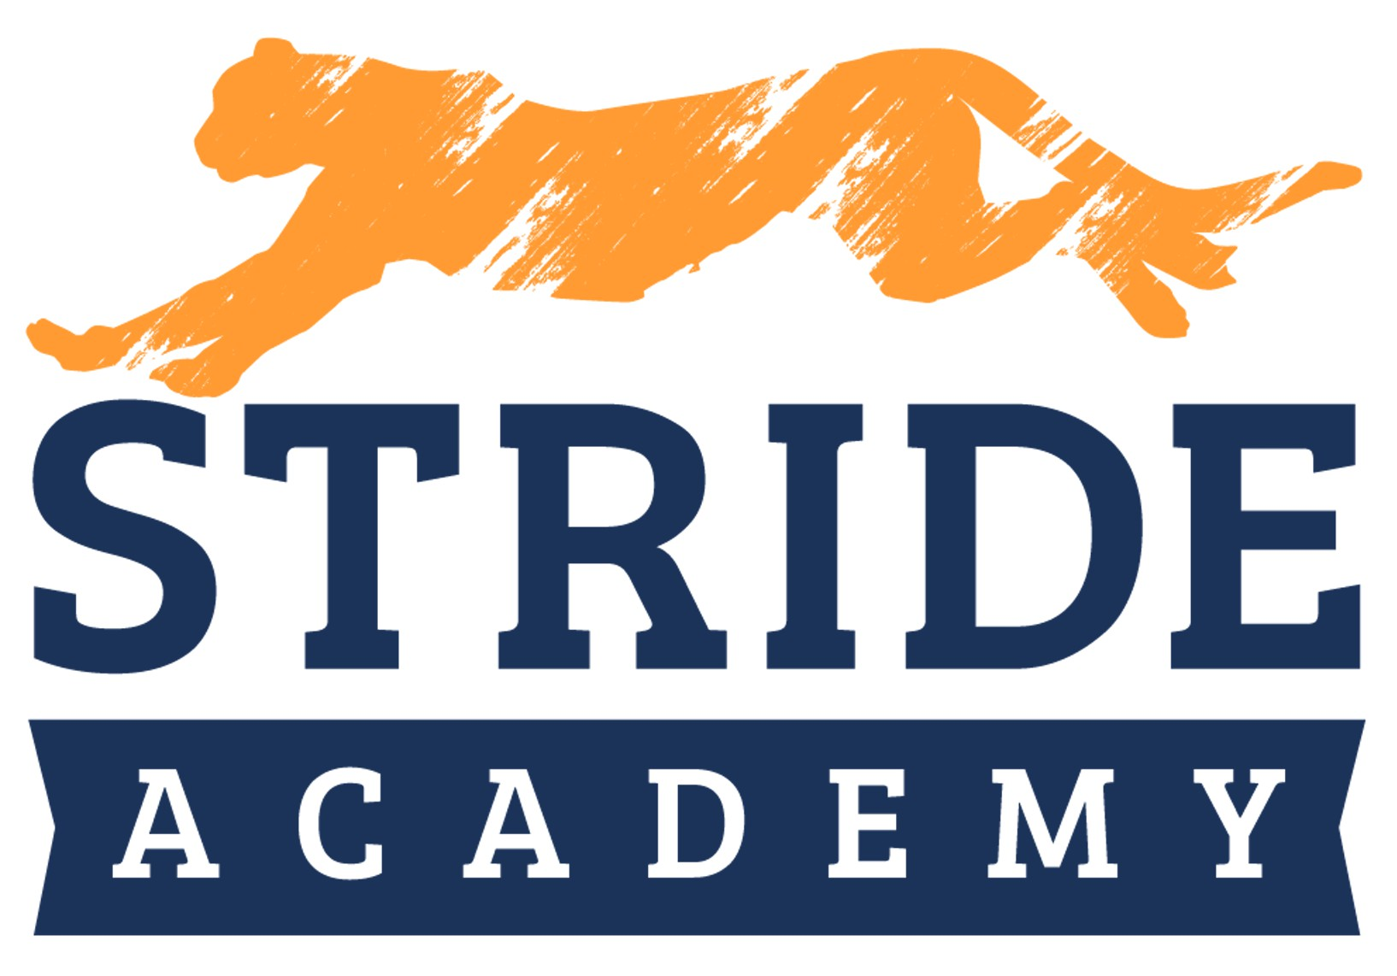

STRIDE Academy World’s Best Workforce
Report

2019-2020 School Year

November 17, 2020

Mission Statement

Stride Academy nurtures individuals while fostering leadership and empowering students to attain their highest potential in a family-centered environment.

Vision Statement

Five Strategic Pillars that support STRIDE Academy: Academic Excellence, The Whole Child, School Community, Lifelong Learning, and Fiscal Responsibility.
STRIDE Academy’s vision is to create a public charter school that is highly regarded for its approach to the whole child, for its academic excellence, and for its contribution in actively serving and improving the community.
STRIDE values effective community collaboration, an increased feeling of physical, social, and emotional wellbeing among students, and positive and culturally responsive practices that increase school connectedness.
STRIDE aims to teach students effective critical thinking skills, in addition to compassionate responses, and high emotional intelligence in order to foster successful leaders of today and of the future.

STRIDE Academy is a K – 7 grade school

Our plan follows the MN Statute section 120B-11 and addresses the following components:
- All children are ready for school.
- All third-graders can read at grade level.
- All racial and economic achievement gaps between students are closed.
- All students are ready for career and college.
- All students graduate from high school.
Under Minnesota Statutes, section 120B.11, school boards are to adopt a long-term, comprehensive strategic plan to support and improve teaching and learning. This plan addresses the following five goals:
- All children are ready for school.
- All third-graders can read at grade level.
- All racial and economic achievement gaps between students are closed.
- All students are ready for career and college.
- All students graduate from high school.

Teacher Equity
The legislation also focuses on ensuring all students have equitable access to excellent teachers. Districts are to ensure they have a process in place to examine the equitable distribution of teachers and strategies to ensure low-income students, students of color, and American Indian students are not taught at higher rates than other children by inexperienced, ineffective, or out-of-field teachers. A short overview has been developed to inform district efforts in this area.

Annual Report and Annual Public Meeting
While the full World’s Best Workforce (WBWF) plan is a multi-year strategic roadmap, each year, districts develop a WBWF Annual Report, engage in an annual public meeting with stakeholders, and release the annual report publicly on district websites. The annual report and annual public meetings are focused on the strategies and initiatives that the district engaged in to meet the goals and the progress made on those goals in the prior school year.

Summary Report Submitted to MDE
World’s Best Workforce legislation requires that districts and charter schools submit a summary of the annual report to the Minnesota Department of Education (MDE) every year. The 2019-20 Progress Report is due December 15, 2020. All districts and charter schools should use the combined World's Best Workforce and Achievement and Integration Summary Report. The link to access this online combined World’s Best Workforce and Achievement and Integration Summary Report will be posted soon. In the meantime, districts and charter schools can use this tool to gather information for their combined World’s Best Workforce and Achievement and Integration Summary Report submission.

Curriculum
Math - GO Math. A curriculum that supports the Mathematical Practices through several specific features including; lessons focused on depth of content knowledge, essential questions to begin lessons, math talk and questioning strategies that promote a student’s use of a variety of approaches to explain their reasoning.

Language Arts - Journeys, a comprehensive Language Arts curriculum with evidence-based results. Its comprehensive reading and writing program facilitates engagement and helps all levels of learners improve. Into Literature is the new curriculum that extends our language arts instruction in grades 7-8.

Science - National Geographic Science Curriculum. Grades K-6 has access to a number of hands-on activities and manipulatives that enhance the exploration of the earth and life science curriculum. The National Geographic Science curriculum aligns with the Minnesota State Science Standards. Generation Genius also supports our science standards in grades K-8.

Barton Reading Program - is a teaching method created for students with dyslexia. It's based on the highly structured Orton–Gillingham approach and is designed to be used by people without educational training (parents, caregivers, relatives etc.…).

In SEL, we utilize three curriculum resources. For K/1, Emotional ABC's (Moody Monster helps kids to broaden vocabulary and understanding of emotions). For 2/3/4, we use Sanford Harmony and use Marc Brackett's RULER components (Recognize, Understand, Label, Express, Regulate). For 5/6/7, we use CASEL's resources and some of Sandy Hook Promise's "It Starts with Hello" and "Say Something"
The following are the five identified areas that STRIDE Academy will continue its efforts toward, and are a part of our continuous improvement plan. This table aligns the systems/goals with the required components of WBWF.

Continuous Improvement:
Student Learning
- Utilize large and small group instructional strategies to help students increase their social/emotional skill levels as well as their problem solving, and collaborative skills.
- Design lessons that are matched to student needs based on data from a variety of sources including standardized and classroom assessments.
- Utilize a system of questioning that triggers higher order thinking. The principal will train staff in the
  - Questions for Life model that utilizes cue words that have been proven to trigger various thinking patterns.
- Continuously strive for high student engagement. Lesson plans include elements of how the students will be interacting with the concepts. Student engagement will be a focus area for staff meetings, professional development, and teacher observations.
- Utilize differentiated instruction in the classrooms. Teachers will be trained in a three- tiered model. Lesson plans and observations will focus on this area. Special emphasis will be placed on utilizing Zones of Proximal Development so as to best help students grow.

Examples:

All Students
Ready for School

All students
in third grade achieving grade level literacy

Closing the Achievement Gap
Achieve Academic Success

Offer Kindergarten Open House opportunities for parents.

Literacy Plan MAP Testing Rock ‘n’ Read FAST Bridge
Dyslexia Screening

Employ 3 EL Teachers, 1
Reading Support Teacher, 1 Title Teacher, 2 Dyslexia teachers and 2
Dyslexia Paras

(MTSS) Tier 1 &
2 classroom interventions.

Use of interim assessments to identify gaps in skill development.

Teachers’ use of Data Warehouse software (Viewpoint) to inform their instruction.
Maintain Fiscal Responsibility

The school intends to gradually increase enrollment of Kindergarten to maximize lease aid in effort to meet bondholder obligations.

Use of ADSIS money to help support STRIDES for Learning Dyslexia Program

Utilize Title I funds and Compensatory Aid to hire the needed teaching positions to support students.
Increase Stakeholder Satisfaction

Annual review of parent surveys in February.

Spring and Summer Kindergarten Open House Meetings
Winter, Spring and Summer Parent/Student Tours
Annual review of parent surveys.

Parent Teacher
Conferences

Annual review of parent surveys.

Use of See Saw

Curriculum Night
Ensure Excellence in Teaching

Q-Comp. Hire Qualified
Teachers. Ongoing Professional
Development
Weekly Professional Learning
Communities (PLC’s) Teacher Evaluation

Q-comp Peer Evaluators

Title II plan/Mentorship and
Induction

Professional Development

Q-comp tied to Student Assessment Performance on MCA’s and MAP’s.

Title II plan

Culturally Responsive Professional Development through PLC and Staff Development Time

Teacher Evaluation
Growing the
School

The school has opened up its facility for Reach- Up, Head Start to have a classroom as STRIDE

Maintaining small class sizes in comparison to Local District

Adding two 8th Grade sections with smaller sizes in comparison to Local District.
Academic Performance
MCA III (Minnesota Comprehensive Assessments)
2019-2020 Data Not Reportable

National Normed Assessments
Each year, STRIDE administers a nationally normed assessment in each grade.
Last year the School administered the Northwest Education Assessment’s (NWEA’s) Measures of Academic Progress (MAP), in both reading and math, in grades K through 7 in September and January.

As part of the School’s agreement with the authorizer (Pillsbury United Communities) at least 95% of students in each grade took both the reading and math assessment in both September 2019 and January 2020. At least 95% of all English-Learners took the reading and math assessment in both September 2019 and January 2020. At least 95% of all students qualifying for free or reduced priced lunch took both the reading and math assessment in both September 2019 and January 2020.

The school’s goal was that at least 55% of the students, who scored below the 51st percentile on the September 2018 assessment, demonstrated “on target” growth on the January 2019 assessmen

The table below lists the specific percentages for each grade in reading and math.

Grade Reading
Kindergarten 75%
1st Grade 58.6%
2nd Grade 28%
3rd Grade 56%
4th Grade 78.2%
5th Grade 67.8%
6th Grade 63.1%
7th Grade 66.6%

Grade Math
Kindergarten 60.6%
1st Grade 74.1%
2nd Grade 60.8%
3rd Grade 55%
4th Grade 82.1%
5th Grade 43.3%
6th Grade 62.5%
7th Grade 62.5%

Teaching
Teachers are trained to align the standards to their curriculum. They created classroom assessments that are used in Reading and Math. The goal is to have standards, curriculum, and assessments aligned.
School leaders used templates for data analysis to conduct in-depth discussions with each teacher. STRIDE uses Viewpoint, a data warehouse tool that allows teachers and administration to examine all student data (academic, behavior, attendance and grades) to inform instruction and additional interventions.
Data analysis and Culturally Responsive teaching will be two of the focus areas of weekly PLC meetings.
Teacher observations focus on the use of data in their classrooms to inform their instruction. Opportunities to review student data is provided for grade levels throughout the year.

Instruction
- Questioning strategies that promote higher order thinking
- Small group instruction based on data from teacher created assessments.
- Posting of Learning Targets during lessons.
- Engaging Students
- The Gradual Release of Responsibility Model—I do, we do, you do.
- Differentiated Instruction

Flexible Grouping:
The educational program at STRIDE Academy is focused on providing differentiated instruction. STRIDE Academy implements differentiated math and reading instruction starting in kindergarten and now continuing through 8th grade. Differentiation allows for both accelerated learning and scaffolded instruction to meet the needs of all learners. Parents are informed of the School’s approach before they enroll at STRIDE Academy. Differentiating instruction ensures that students will have appropriate challenges to provide opportunity for growth. If they are below grade level, focused interventions help students receive focused attention in areas of need. If students are above grade level, flexible grouping helps students receive enrichment-focused opportunities with attention focused on standards, problem solving, and critical thinking. Given our Student-centered focus, differentiated instruction is an accepted practice by parents, students and staff. To accomplish appropriate differentiation, all students are pre-assessed in math and reading. The assessment data is used throughout the year to place students in their flexible skill groups. Student confidence and success increase when they are instructed with a differentiated model. Multi-Tiered Systems of Support allows the School to monitor student data and make adjustments throughout the year. The use of a Multi-Tiered System of Support (MTSS) strives to ensure that student needs are being met. Systems are created to allow for universal screening of literacy and math skills, progress monitoring of how the student responds to the interventions, and fidelity to those interventions.

Strategies for English Learners
• Co-Teaching training and support from school leaders to implement.
• Pre teaching vocabulary.
• Analysis of ACCESS scores matched to the WIDA standards.
• Professional Development in Cultural Bias, and Culturally Responsive Teaching.
• Purchase of online curriculum that has been proven to support learners as an intervention in the acquisition of language and math skills.
• Depending on levels of learners, create a program based on needs. More intense instruction for Level 1 English Learners. Accelerate the growth of students who are below level by doubling course time in those areas.

Best Practice Instruction
Principal conducts at least 3 formal observations a year per teacher, followed by feedback and a reflective conference.
Utilize goal setting with teachers after each post observation meeting (19-20) Establish focus areas of differentiated instruction; questioning strategies; and small group instruction based on student need.
Provide support for each area above by providing training and participating in planning sessions and
PLCs.
Review lesson plans with teachers; weekly for those teachers needing more support.
Train teachers in Dyslexia identification and support. Establish a referral process to the Dyslexia
Specialist.

EL Students
• Analyze ACCESS data and match to WIDA standards.
• Provide for training opportunities in Co-Teaching.
• Schedule classes so that co-teaching can occur.
• Create models for different levels of learners.
• Purchase online curriculum to assist with language acquisition, especially in math.

Culture for Learning
• All staff will create a culture of high expectations for ALL students.
• Introduce PBIS so that consistency in creating a positive culture will be attained.
• Differentiated Instruction will create opportunities for discussion of its use in place of ability grouping to avoid cultural bias.
• Culturally Responsive Teaching Training occurs during weekly PLC time and on professional development days.

Relationships with Families and Community
• Leaders and staff will utilize a variety of means to communicate with families. (Email, Phone, SkyAlert, Thursday Folders)
• Principal is a member of the St. Cloud Rotary as a way to let the community know about STRIDE.
• Skyward training is provided throughout the year for families to become comfortable with its use.
• Parents are informed of major changes at STRIDE. Opportunities for discussion are provided and encouraged.
• Cross promotion and radio advertising brings awareness of STRIDE Academy to the greater St. Cloud community.

Q-Comp Professional Development and Professional Learning Communities:
To assist in the implementation of the Q Comp Plan, 5 Teachers have been assigned as part time Peer Evaluators to observe their colleagues. The Peer Evaluators observe teachers in the classroom setting, evaluate their work using school-approved rubrics, and coach them for improvement throughout the year.

These five positions are compensated through stipends for the work as Peer Evaluators in addition to their full-time teaching duties. The peer evaluators are trained in the use of the school-approved rubrics for effective instruction, including data-gathering strategies and conferencing skills. In this training, Peer Evaluators develop the skills necessary to rate the teaching of their peers with validity and reliability.

The training in August for all teachers was focused on designing specific classroom-based strategies for creating a productive learning environment. Specifically, teachers were trained in strategies designed to reduce the number of disruptions to the learning process, and to increase the amount of time that students are productively engaged with content designed to improve student learning.

Professional Learning Communities meet weekly to communicate and collaborate in follow up activities directly related to Q-Comp goals related to instructional practices. The PLCs will also set goals for their working groups, as well as individually to embed professional learning into their daily practice.

Each teacher is assigned to a PLC, with meetings held weekly, and teachers are expected to attend. Attendance at these meetings is important as job-embedded professional development activities, described above, occur on a regular basis in PLC Meetings. For the 2019-20 school year at STRIDE, the content of the professional development activities was built around the work of Sharroky Hollie, specifically his training program Culturally and Linguistically Responsive Teaching, 2015, Shell Education, Inc.
This training was be conducted by both teacher leaders and building administrators, and teachers had the ability to use this training to tailor their teaching to a student body of increasing diversity and complexity in learning needs. Teachers used the training to make modifications in their teaching practice that have demonstrable impacts on students, there will be a performance pay stipend for their efforts. Specifically, in order to earn the full merit pay stipend for PLC initiatives, the teacher must have a documented attendance level of 85% or greater, as evidenced by minutes of the PLC meetings between Sept. 1, 2019 and May 15, 2020.

Additionally, by May 1, 2020, each PLC member must fully implement at least three goals that were initiated through the job embedded professional development process in their PLCs. The building principal will assess the level of proficiency in implementing these strategies through a combination of data including direct classroom observation, collection of teacher artifacts, examination of teacher journal entries, and other measures deemed appropriate for measuring the implementation of strategies related to Culturally and Linguistically Responsive teaching strategies. A total of $400 will be available to each teacher who achieves all of the attendance and PLC-initiated goals related to Culturally and Linguistically Responsive Teaching.

The teacher evaluation model.

Use of the Charlotte Danielson-derived rubrics
School leaders use 9 criteria to be evaluated. These criteria closely align with the school’s goals for implementing Data Driven Instruction. This provides the focus for evaluators to function both as Q Comp evaluators, as well as instructional coaches throughout the school year.

For 2020-2021 STRIDE Academy is using peer evaluators as the primary source of assessing the level of effectiveness of teachers in meeting the expectations of the Q Comp program.

Leadership
For the 2019-20 school year, the administrative structure consisted of an Executive Director, and one Principal leading the school’s organization.
The Principal facilitated training in alignment of standards, instruction and assessment.
Culturally Responsive Teaching was a strong focus in PLCs, observation conferences, professional development
Periodic walk-throughs in classrooms were conducted to ensure teachers were teaching to standards.

